**AWS GLUE**

* AWS Glue is a fully manages ETL (Extract, Transform and Load) service that makes it easy for the customers to prepare and load their data for the process/analysis.
* ETL is a data integration process which consist of 3 steps:

1. **Extract**: Take data from the data source.
2. **Transform**: Cleans all the data and convert it to a single format.
3. **Load**: Loading the data in data warehouse.

**ETL Workflow:**

* The data which we want to store can come from different servers like SQL server, RDBMS or from any drive.
* So in **Extract**, the data is extracted from these different sources and collect at once area called ad **Staging Area.**
* In **Transform,** the data is cleaned and as it comes from different sources and servers, it will be in different formats. So it will convert it to a single format.
* In **Load**, the data is taken from Staged Area and loaded into the **data warehouse.**

**Advantages of Data Warehousing:**

* Highly Scalable.
* Increases Speed.
* Efficiency of Data Analysis.
* Combined view of data.

**Advantages of AWS Glue:**

* Easy management.
* Cost efficient.
* Superior functionality.

**Workflow:**

* So the first thing is you need to have the data in you **S3** bucket.
* Now by using **AWS Glue Crawlers** you need to take the data from S3 and it will scan your datasets and also creates a virtual database out of this catalog data and then passes it to AWS Glue Data Catalog.
* The **AWS Glue Data Catalog** serves as a central metadata repository as it contains table definitions, job definitions, and other control information to manage your AWS Glue environment.
* Now you can use this services from different kinds of service and you can integrate them with other AWS services like Amazon EMR, Amazon Redshift, Amazon Athenaetc..
* Now as you have warehoused your data you can use data visualization tools with it like Amazon QuickSight and many more.

Now we will be crawling some data out of Amazon S3 and then we will put it back to S3 after we catalog it.

**Create S3 Bucket:**

* We will create a S3 bucket and create 2 folders in it as **input & output.**
* Now we will upload our sample data file inside the input folder.

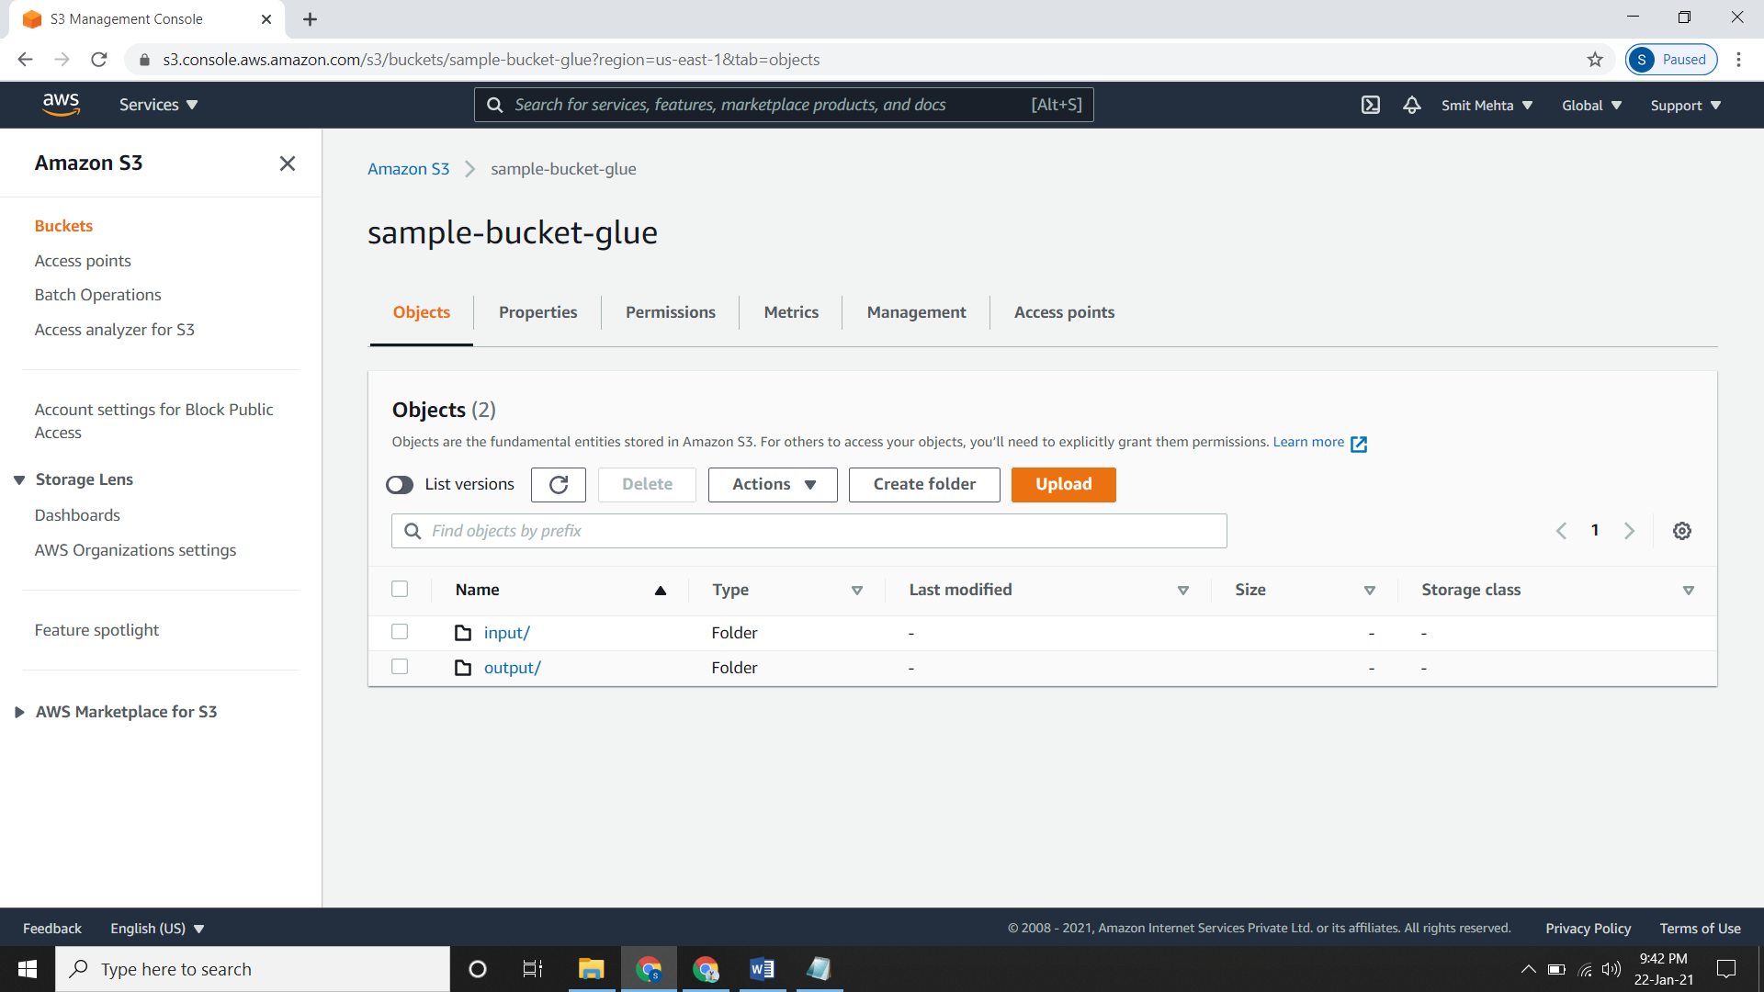

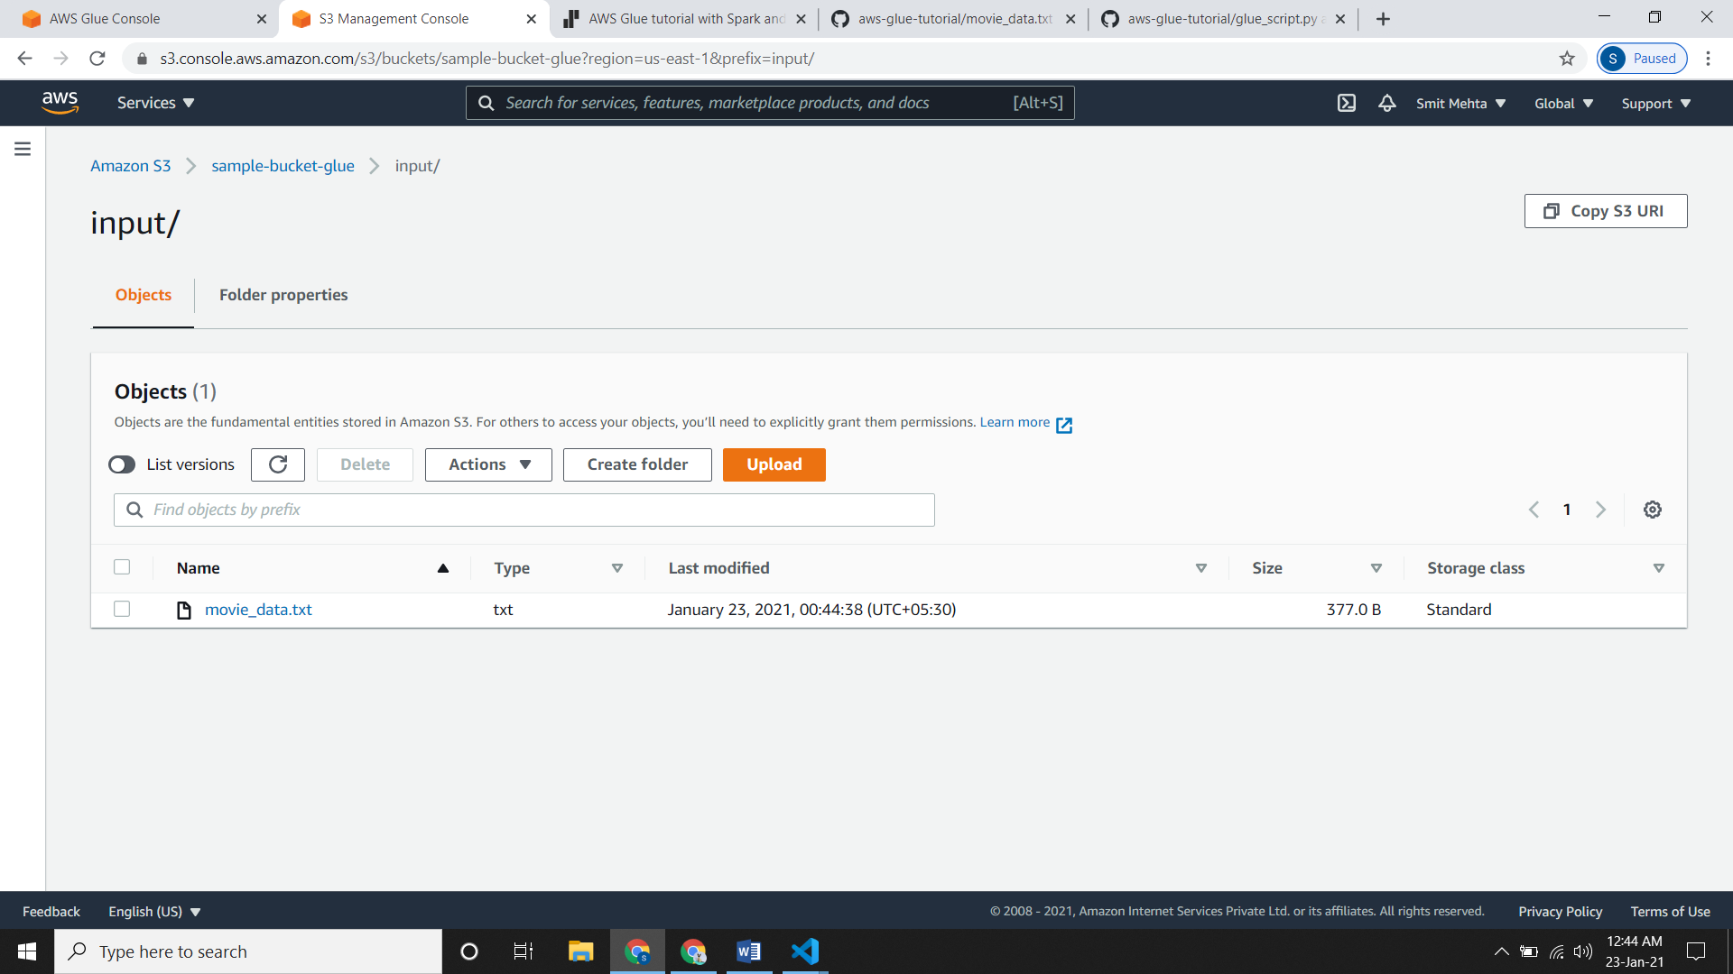

**Creating Crawler:**

* Go to AWS Glue, click on **crawlers** and then click on **Add crawler.**
* Give a **name** and add the **Tags, Description, Security configuration, and Classifiers** accordingly to your requirement as it is optional and then click on **next**.
* Under **Crawler source type** if you need to choose data from S3 click then choose **Data stores** and if you want to choose it from an existing catalog tables then click on **existing catalog tables.**
* Under **Repeat crawls of S3 data stores,** if you want to choose all the folders from S3 then click on **Crawl all folders** and if you want to choose particular folder then click on **Crawl new folders only.**
* Under **Add a data store** choose the **crawl data in** accordingly and select the path for our input file.

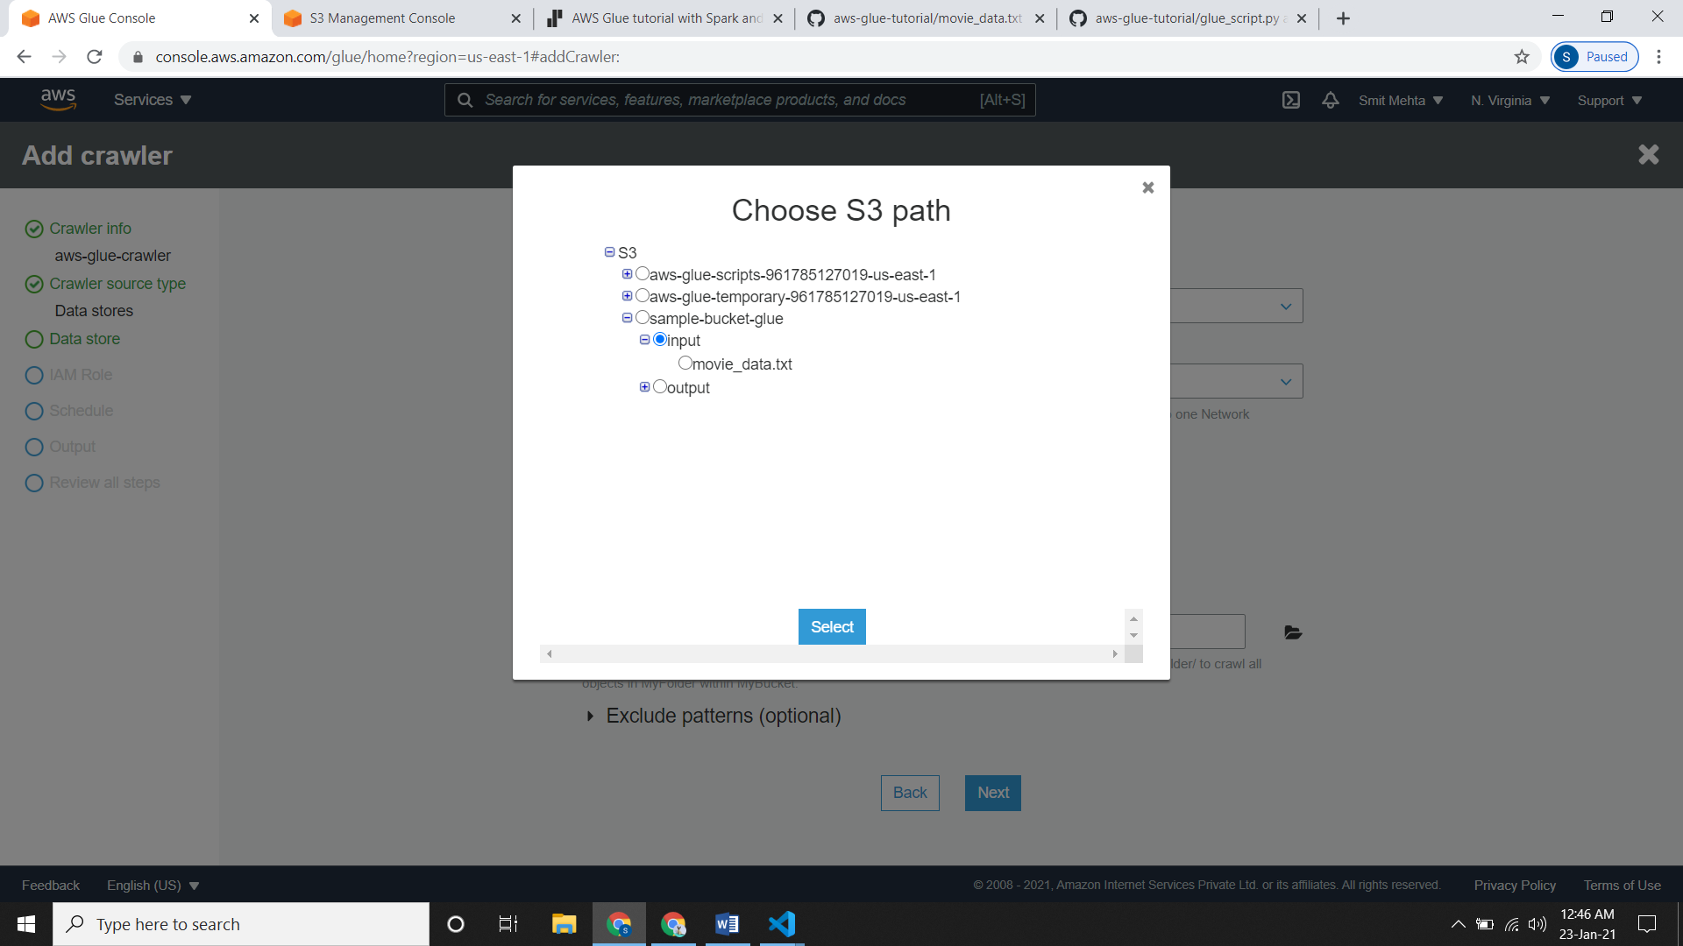

* Under **Add another data store** select the necessary option and click on **next.**
* Now you need to provide an IAM role and if you do not have it then click on **create an IAM role** and give it a name. Click on **next.**

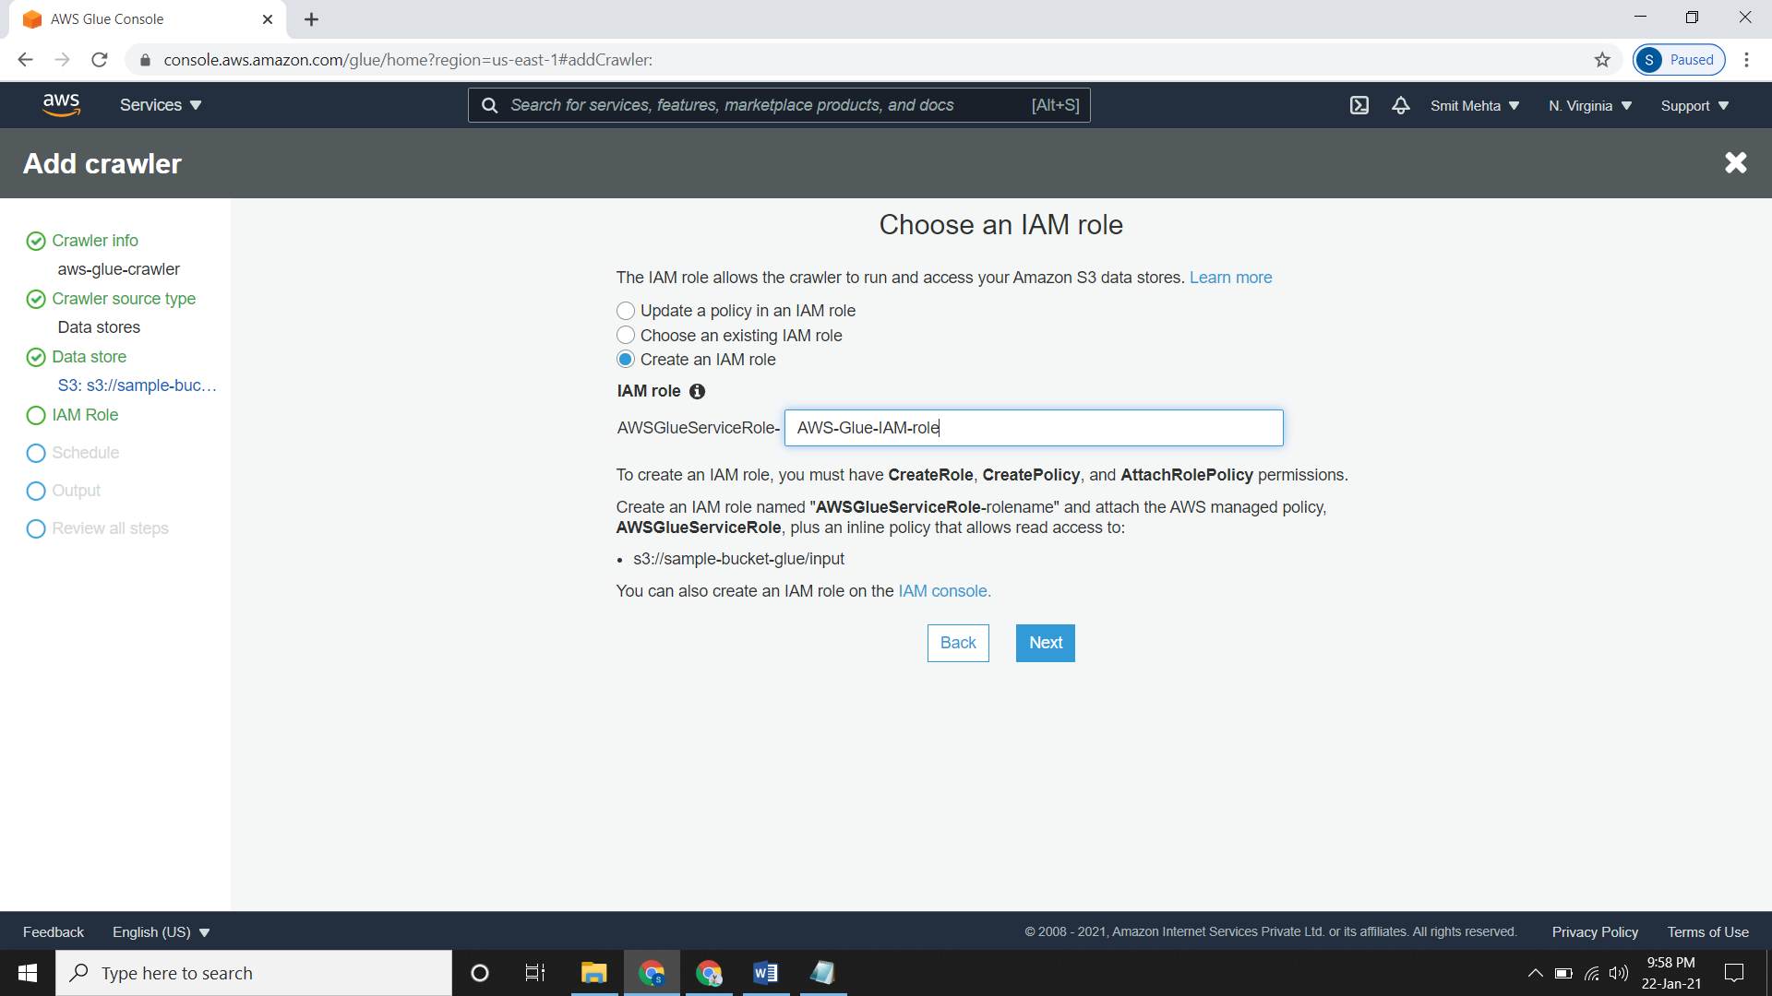

* Under **Create a schedule for this crawler** choose the Frequency that when should the crawler start.

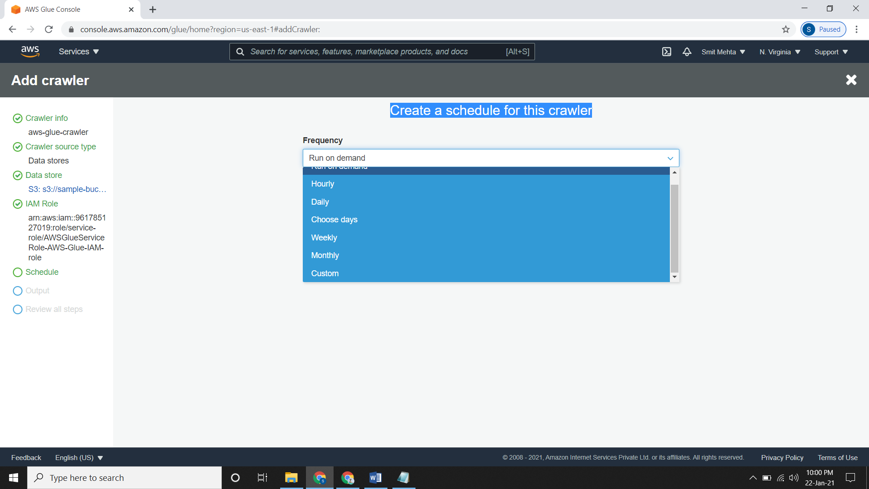

* Under **Configure the crawler's output,** select/add a database, add prefix to tables if required and then click on **next.**
* Now review your crawler and create it.

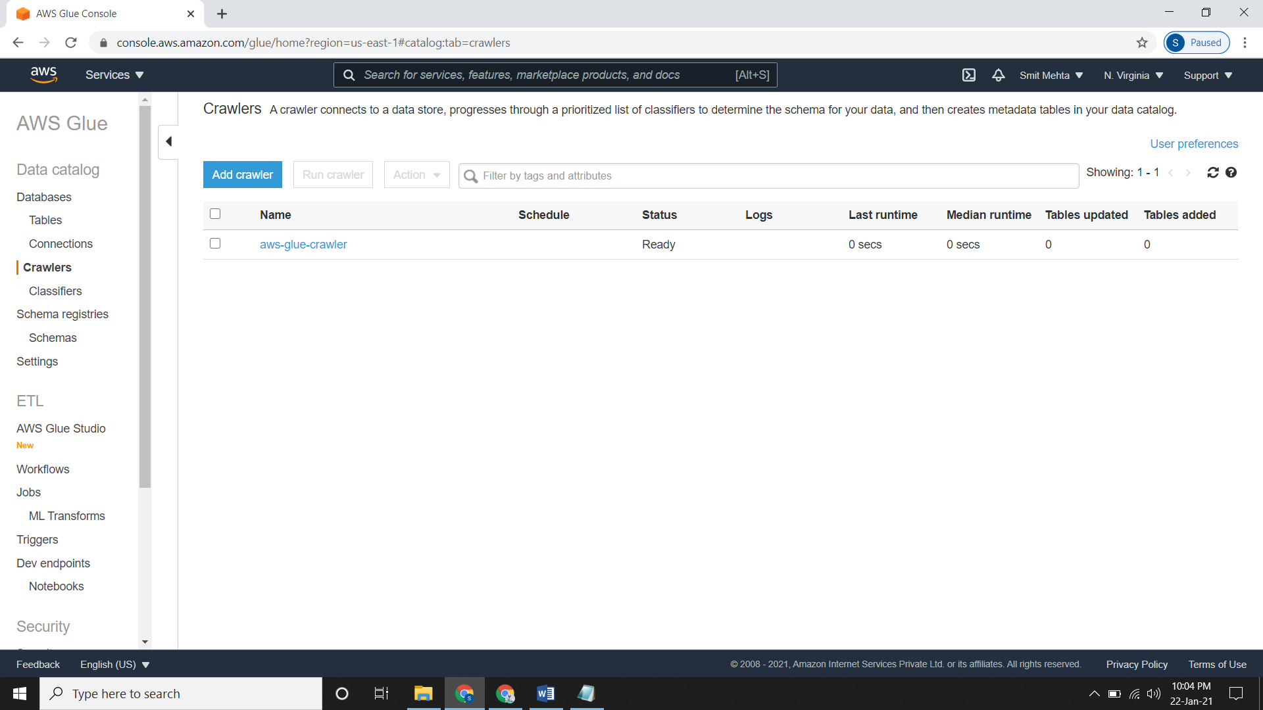

* So under **Create a schedule for this crawler** we have choose the Frequency as **Run on Demand** so we need to run it manually.
* So just select your crawler and click on **Run crawler.**
* Now it will take some time and create a database and catalog in it.

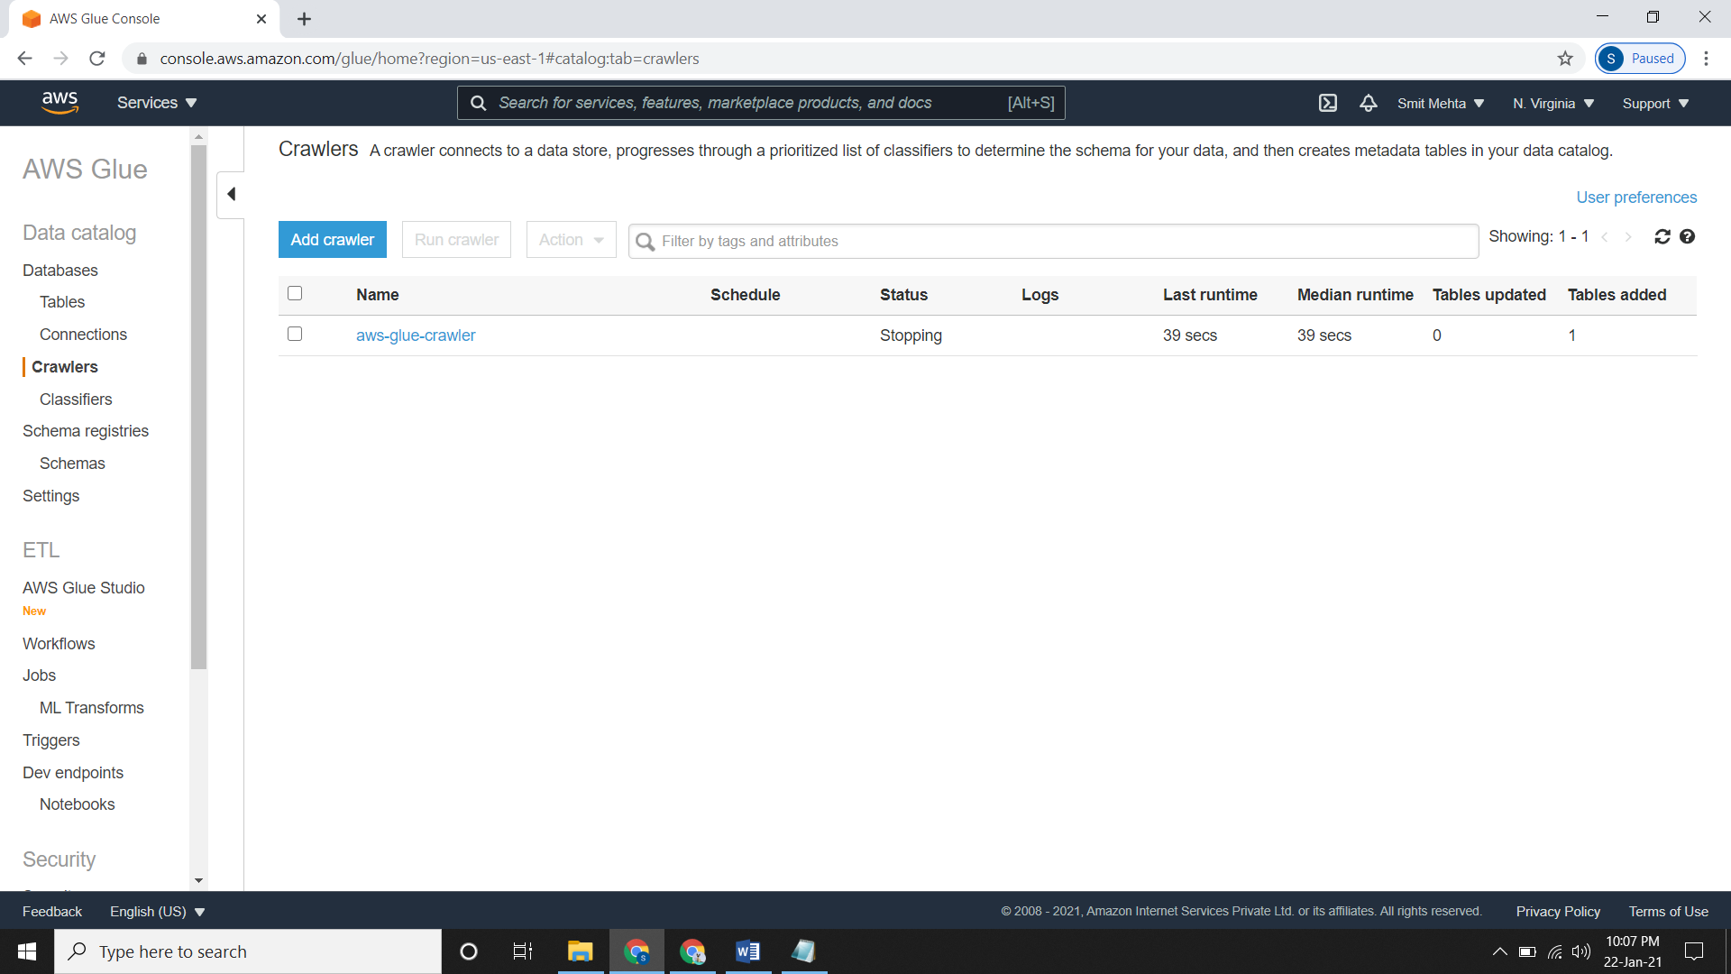

* Checking the database

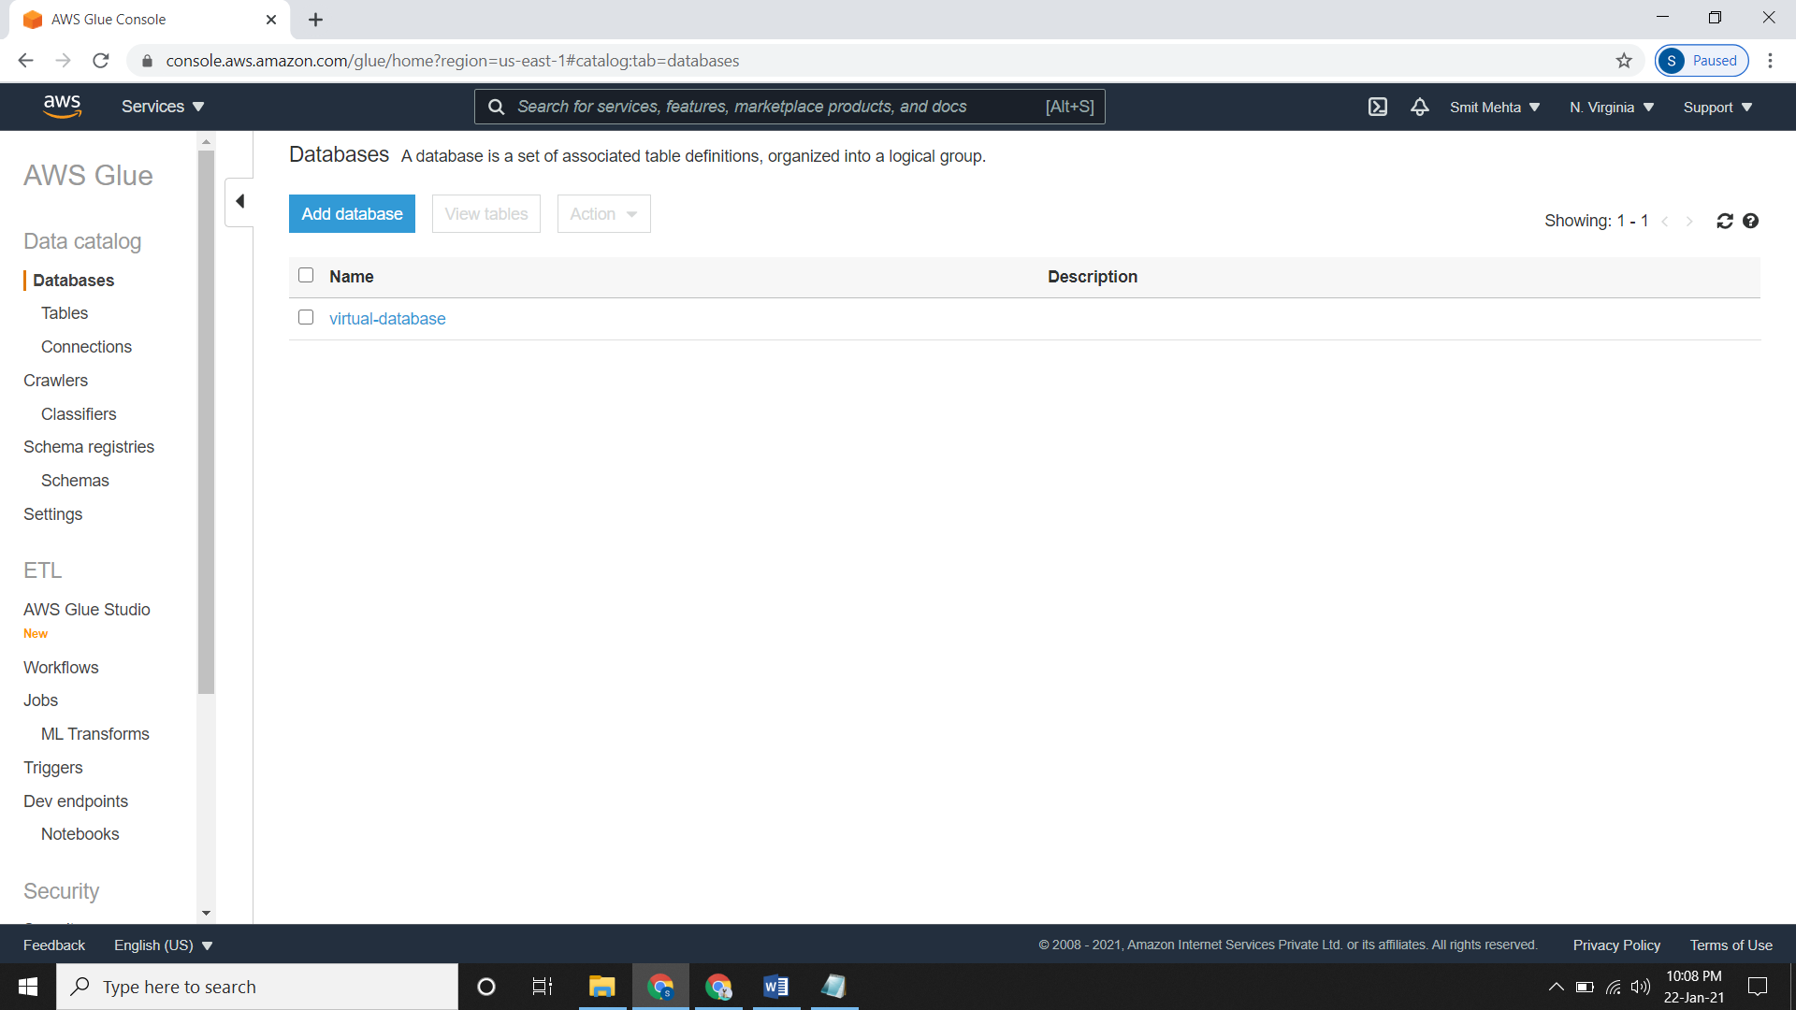

* Now go to the database, open it and click on **Tables in your_database_name** and open your folder you will have your dataset file.

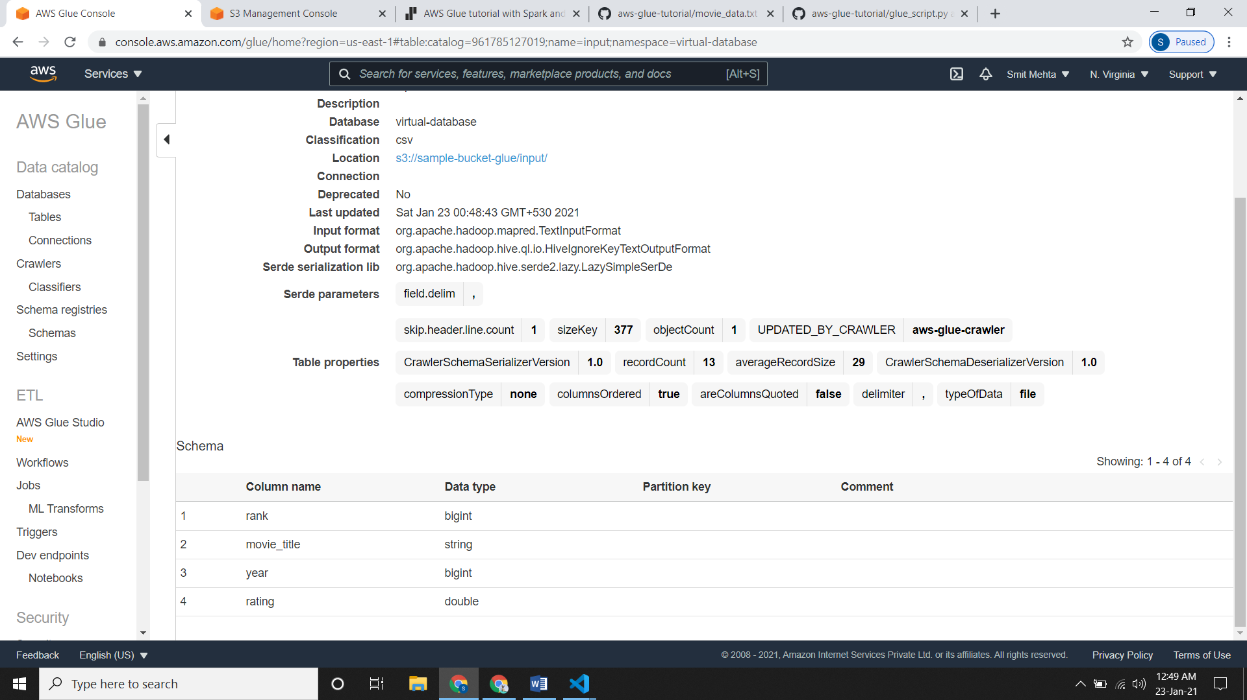

**Creating ETL Jobs:**

* Our metadata is now created so we need to create ETL jobs.
* Go to **ETL,** click on **Jobs** and click on **Add a Job.**
* Give a **Name** and select the **IAM role** which we had created.
* Under **Type** select the language in which you will write the script and choose a version for it from **Glue Version.**
* Under **This job run** select the way in which you want to write your script.
* Now choose **Advanced properties, Monitoring options and Tags** as they are optional.
* Under **Security configuration, script libraries, and job parameters** reduce the **worker type, number of workers, job timeouts** accordingly as you are working firstly or working for practice.

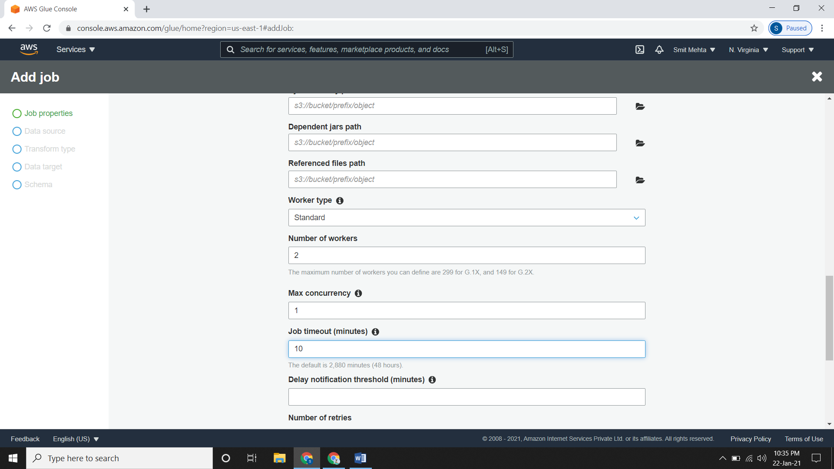

* Now choose the particular data source.

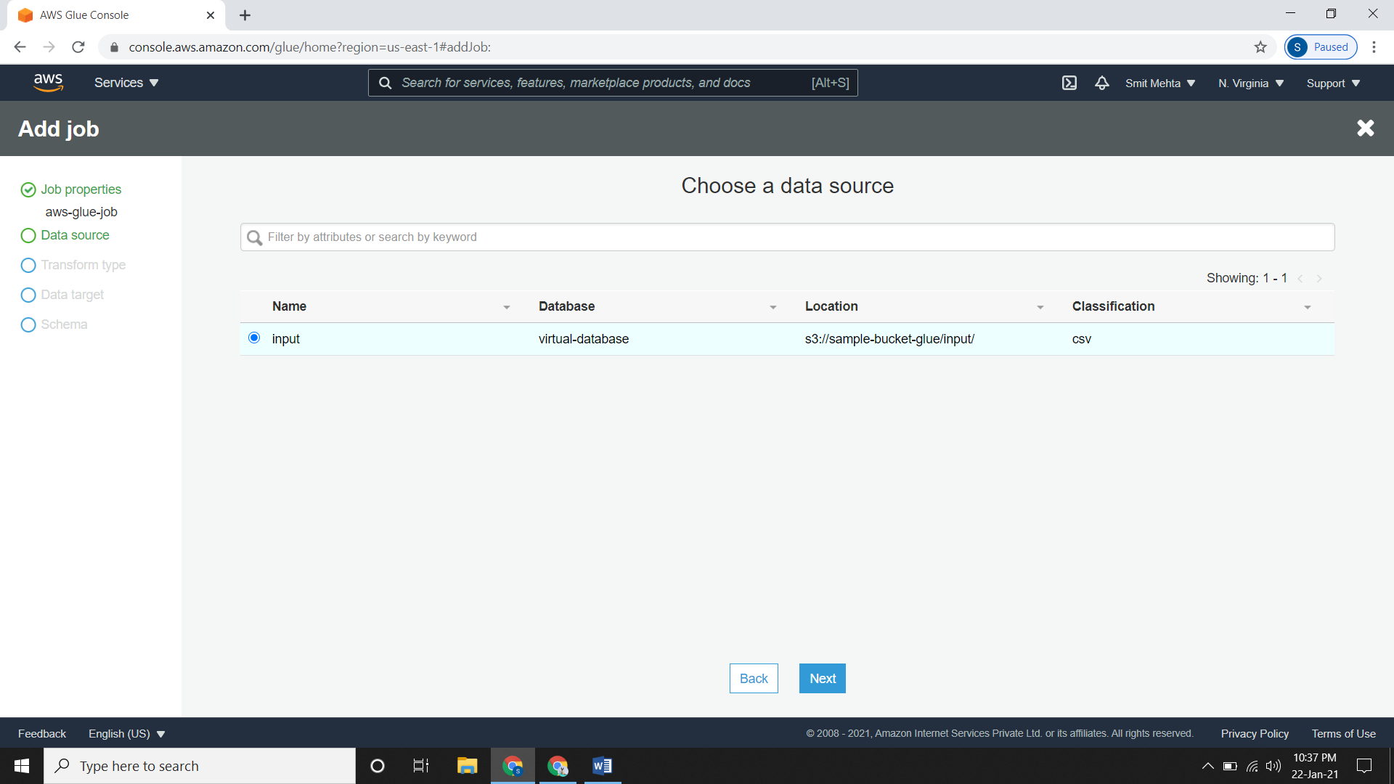

* Under **choose a transform type** just select the default one and click on **next**.
* Under **choose a data target** select the target you want.

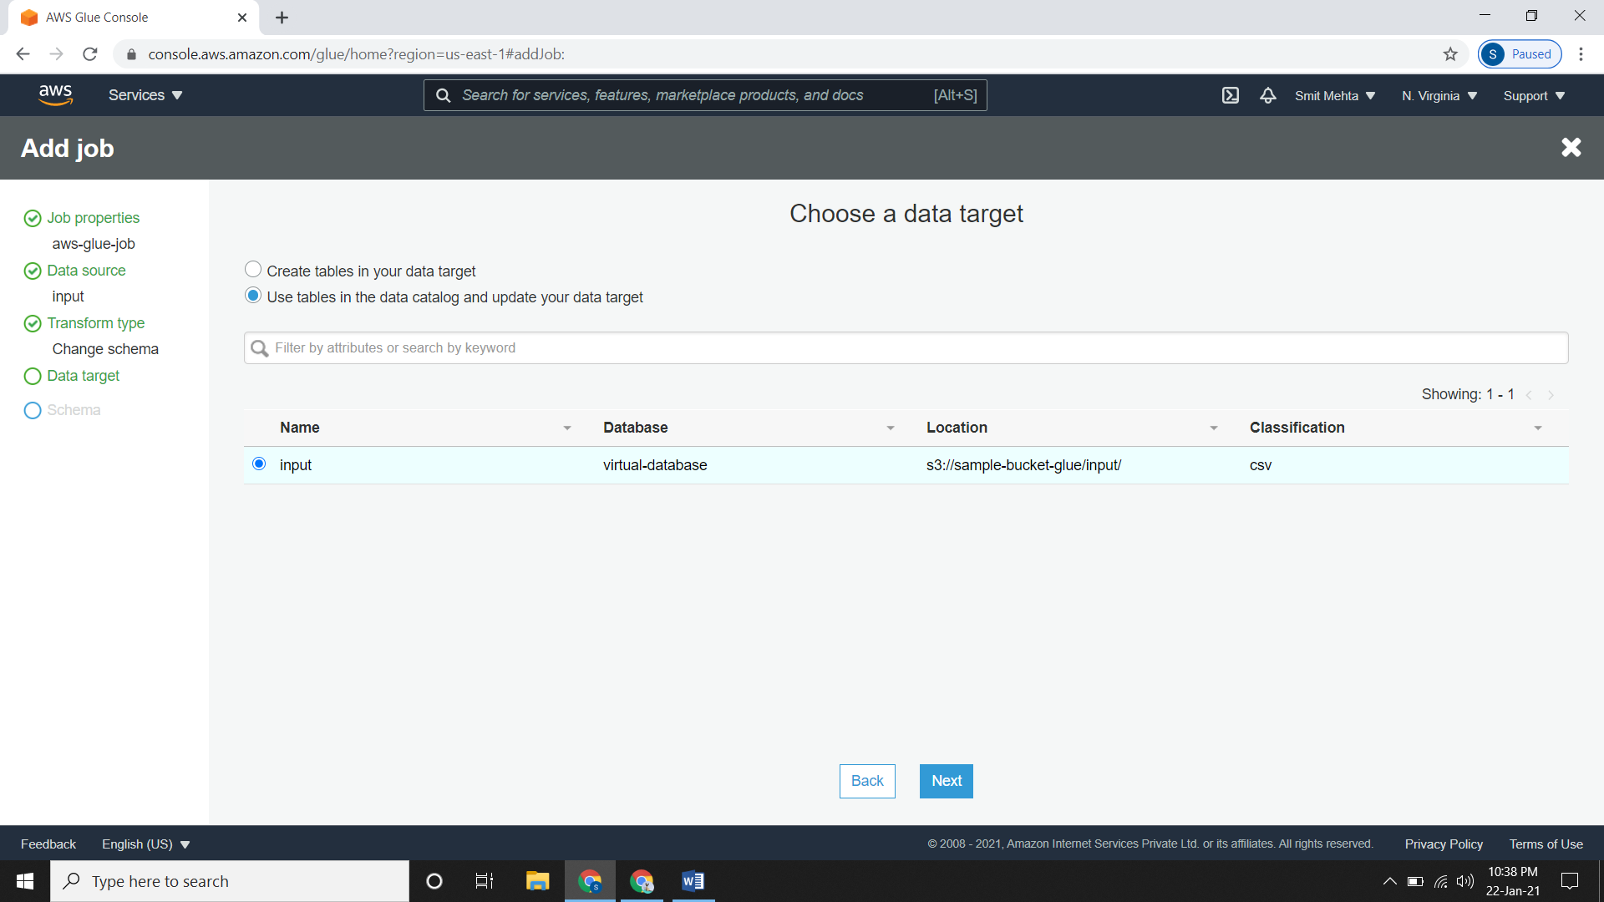

* And finally in the **Output Schema Definition** you will see the changes done in the datatypes.

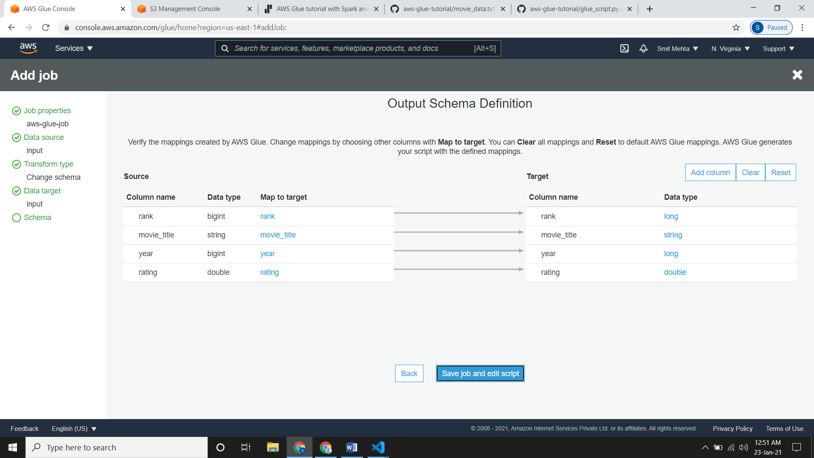

* Now click on the **Save job and edit script** and a new tab will open up with the written script.

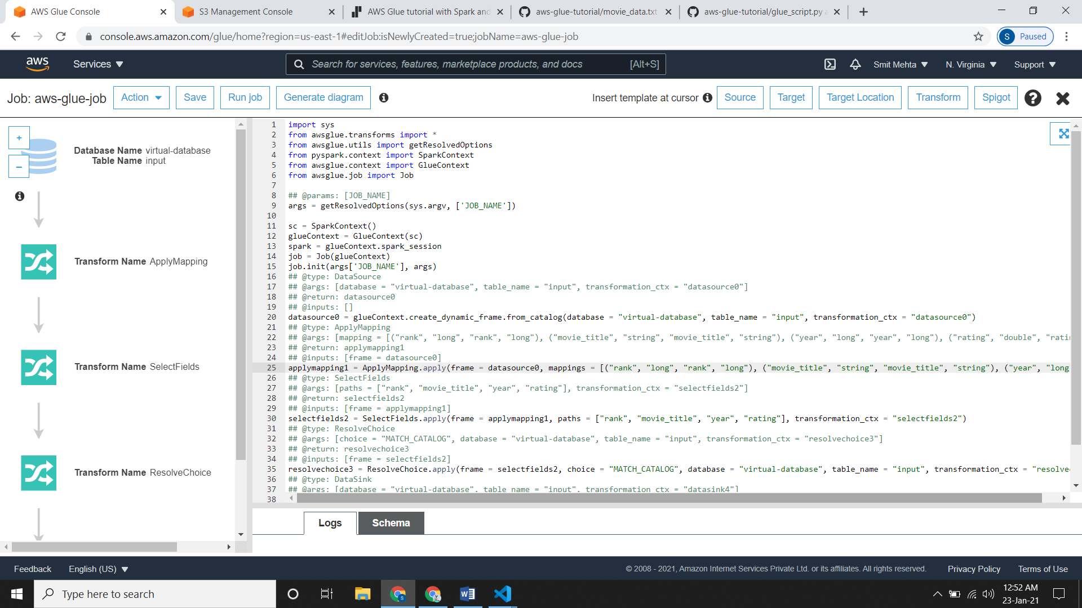

* So we have our own script according to our dataset so just copy it and paste it over here.

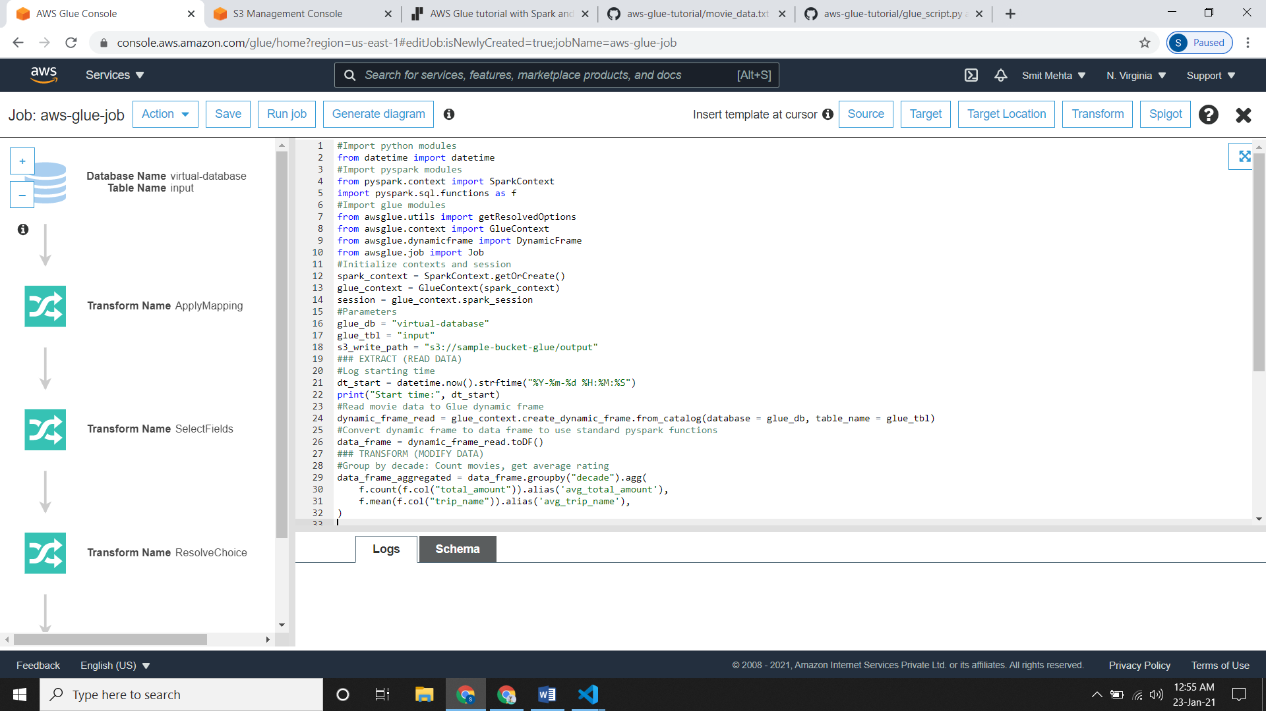

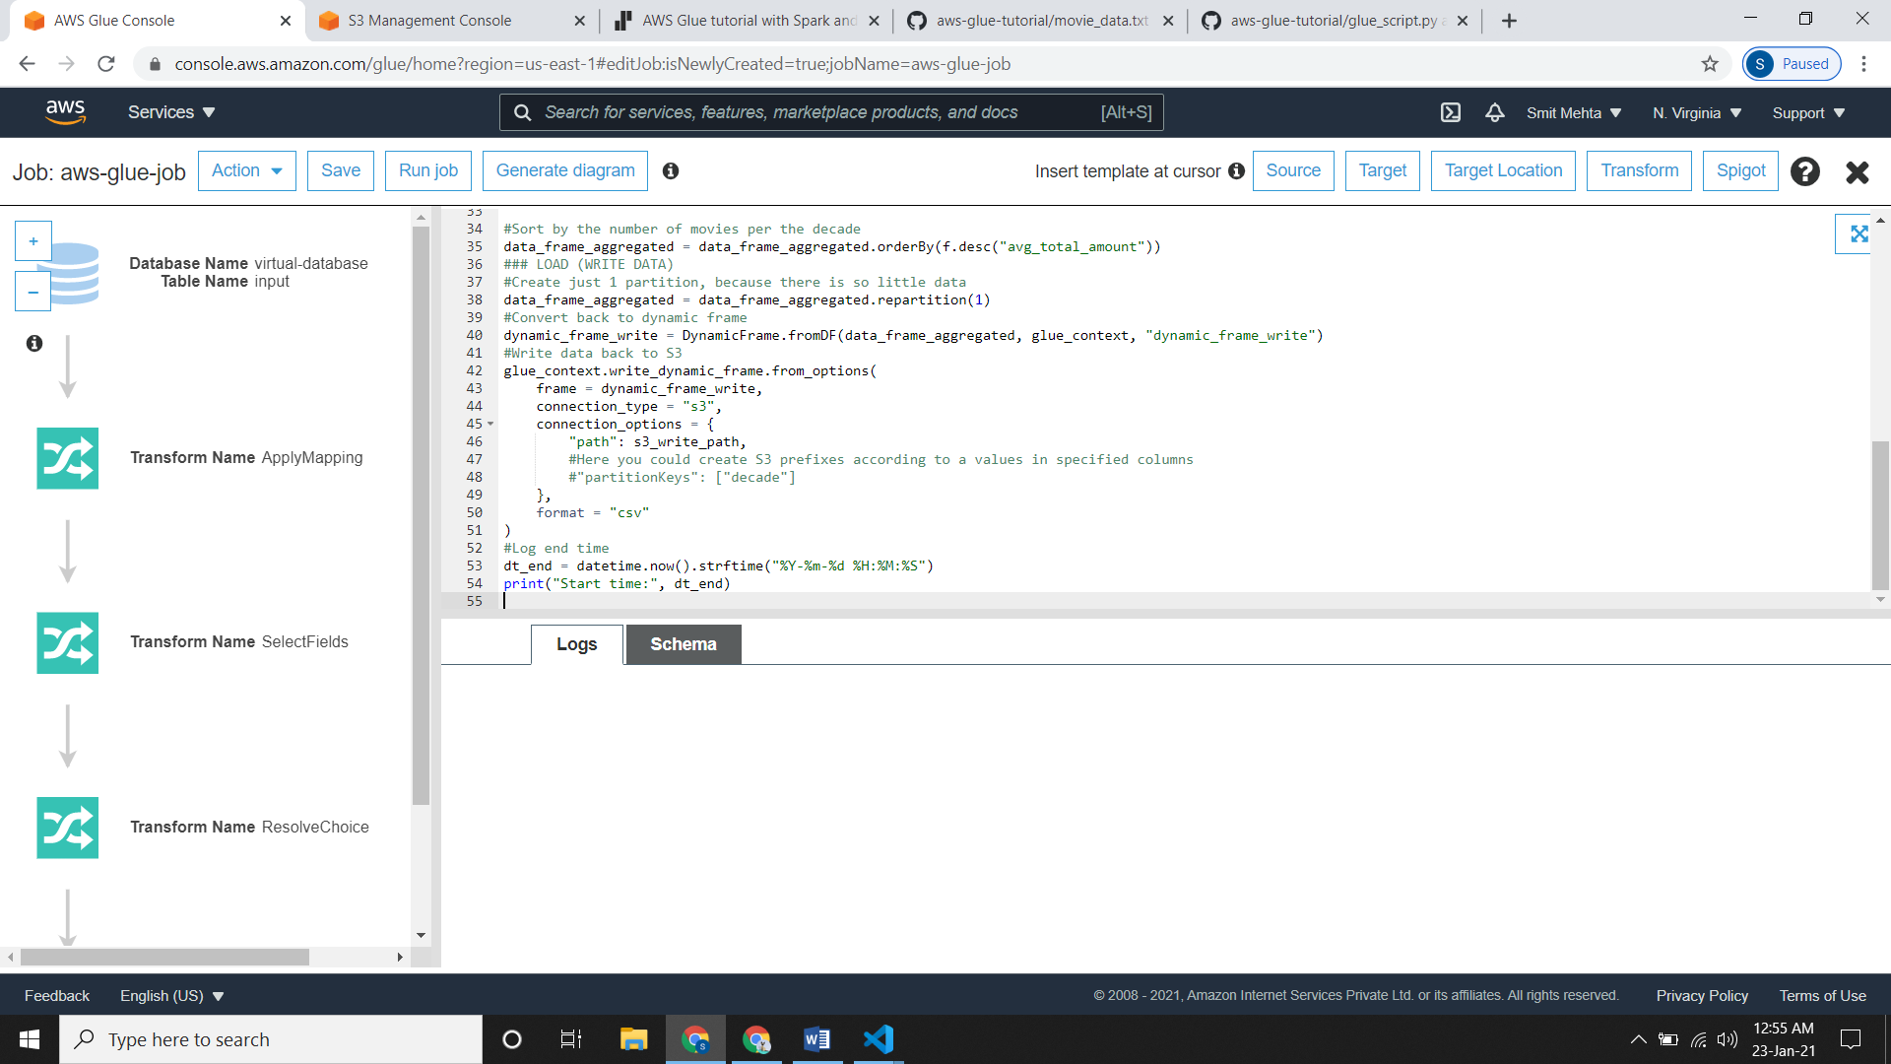

* Now you need to save your file so click on **Save** and then click on **Run** for running the script and it will take some time.
* So after your job has successfully run, check the output folder inside your bucket you will see the output files there.

**Importing Files from S3 to Redshift**

* Steps for Importing files from S3 to Redshift

1. Create S3 Bucket and upload the files.
2. Create Amazon VPC Endpoint for S3.
3. Setting up a VPC to connect to JDBC Data Stores.
4. Create AWS Glue Crawler.
5. Create Amazon Redshift Cluster.
6. Create JDBC Connection.
7. Initialize ETL Job.
8. **Create S3 Bucket and upload the files:**

* First create a S3 Bucket and then upload the file in there.

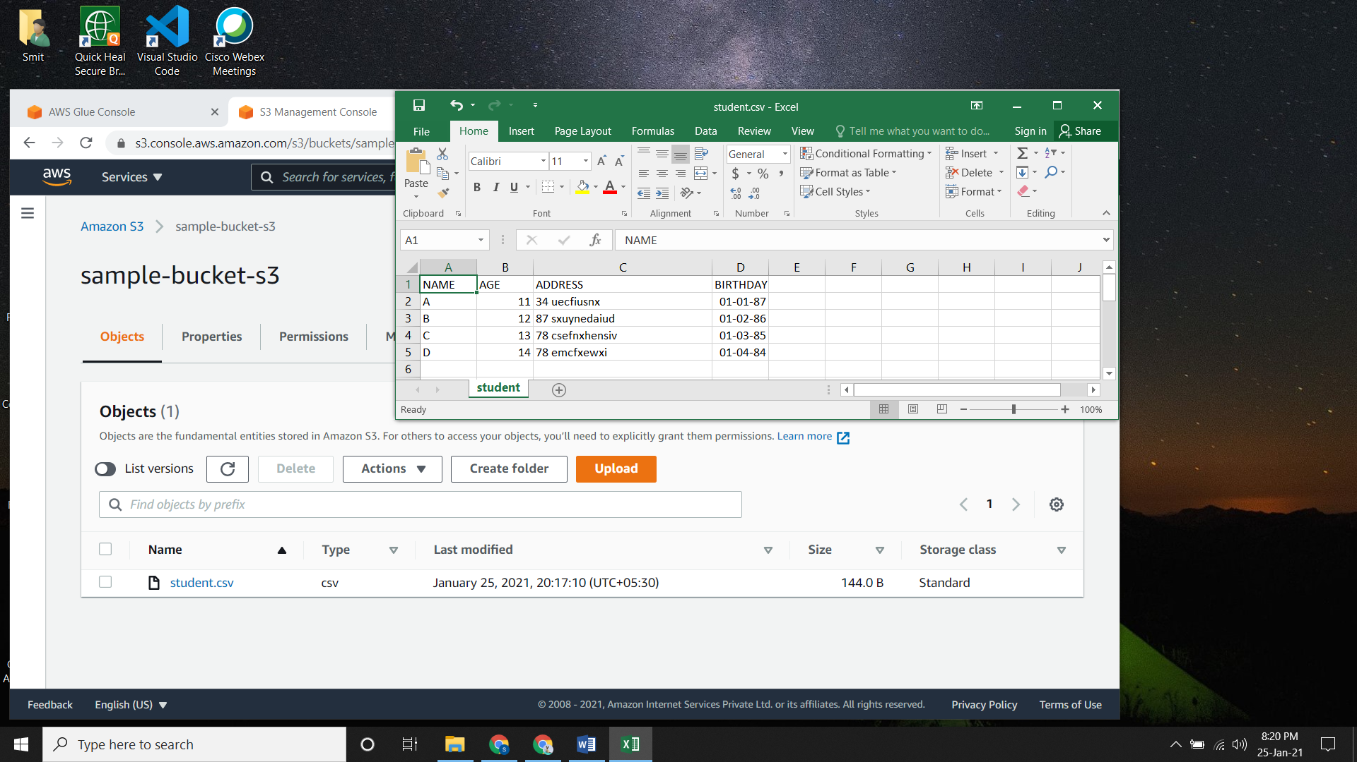

1. **Create Amazon VPC Endpoint for S3.**

* Go to the VPC Dashboard and click on **Your VPC.** This will be your default VPC.

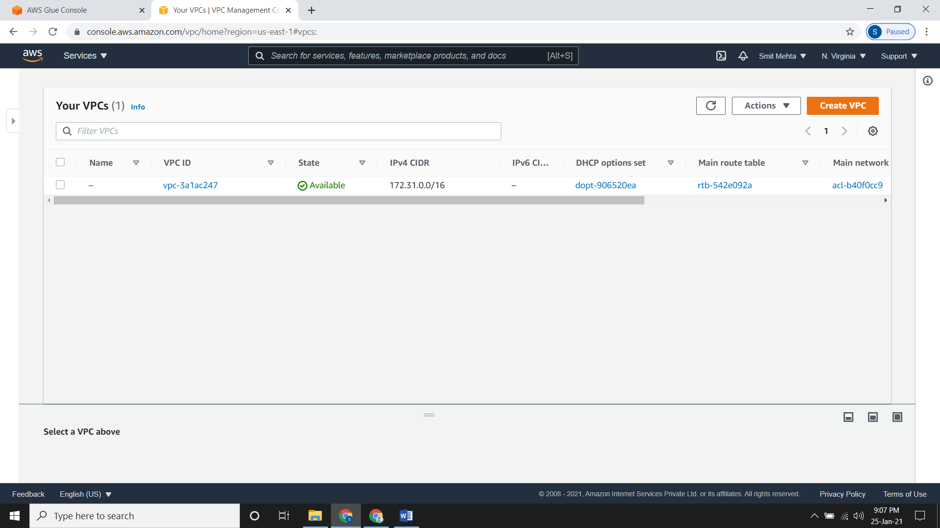

* Now click on **Endpoints** and create one.
* Select the **Service category** and select the required **service name.**
* Now scroll down and under **Policy,** select the default policy or create a custom one.
* Now click on **create endpoint.**

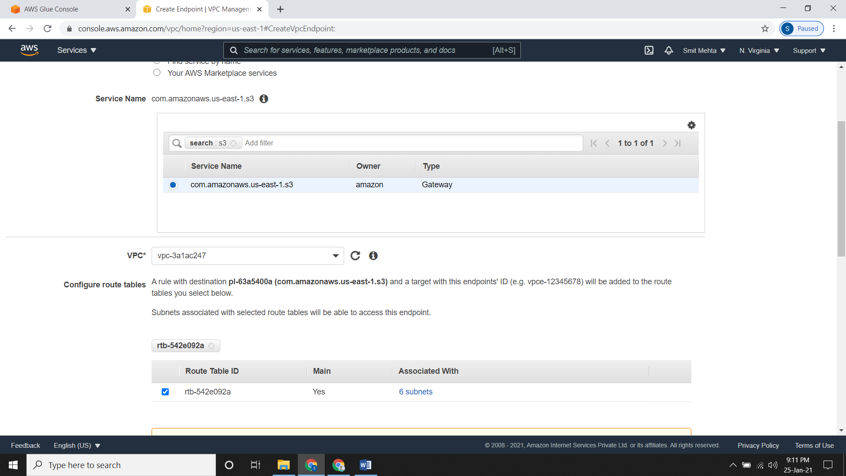

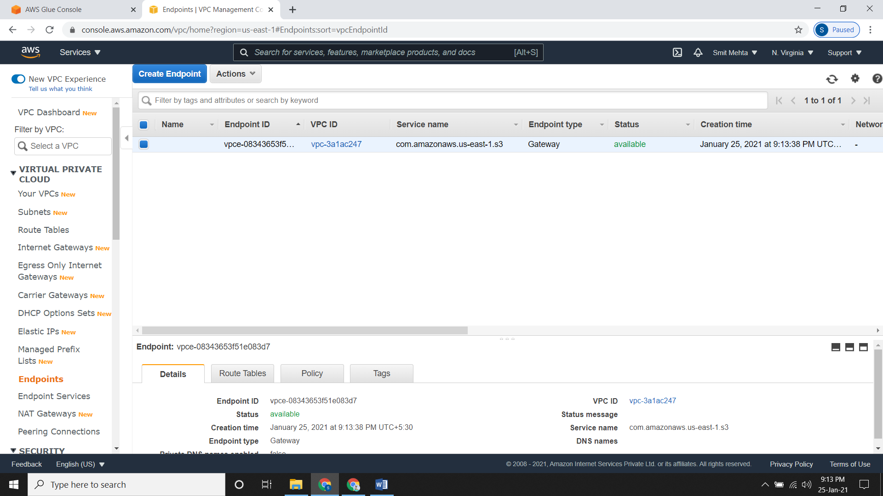

* If you check the **Route Tables**, under this click on **Routes** you will see a Destination allocated to your Target i.e. your selected VPC.

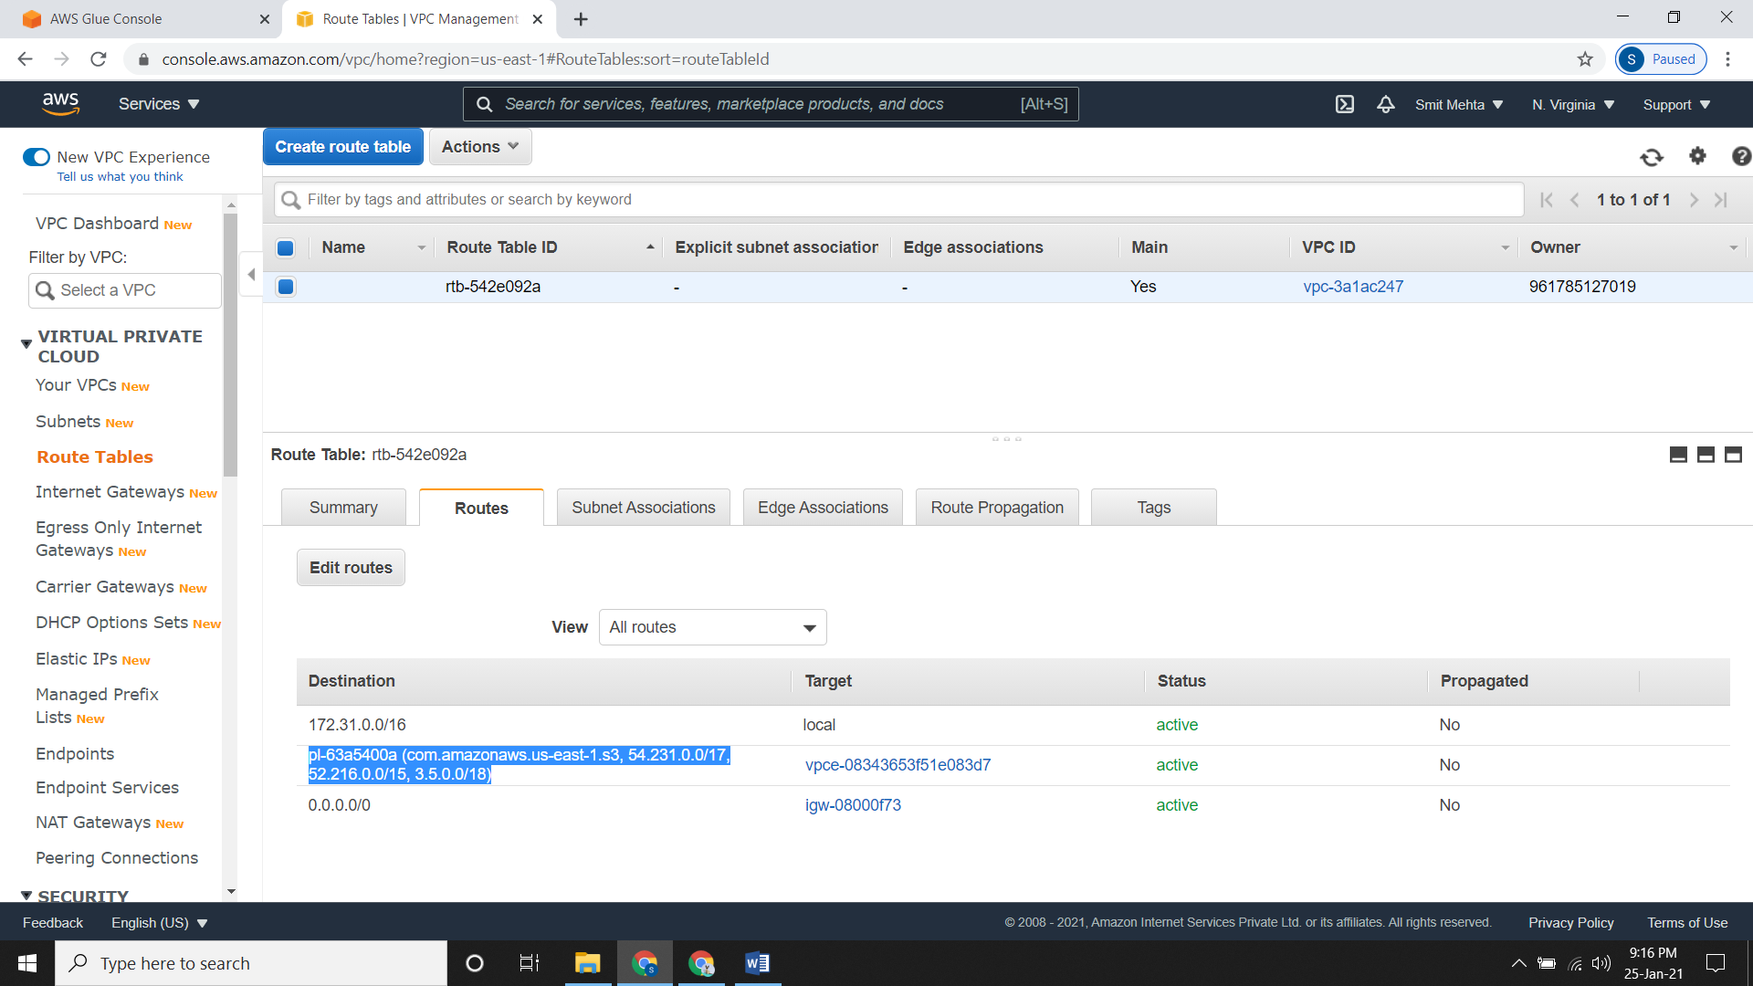

1. **Setting up a VPC to connect to JDBC Data Stores.**

* For this we need to create a different **security group** and attach it to this VPC.

Under VPC go to **Security** section, click on **Security Groups** and create a new one.

* Give a **Name, Description** and select the **VPC.**
* Now click on **Add Rules** in **Inbound rules** and give a rule as type = **Redshift** and source = **0.0.0.0/0** and create it.

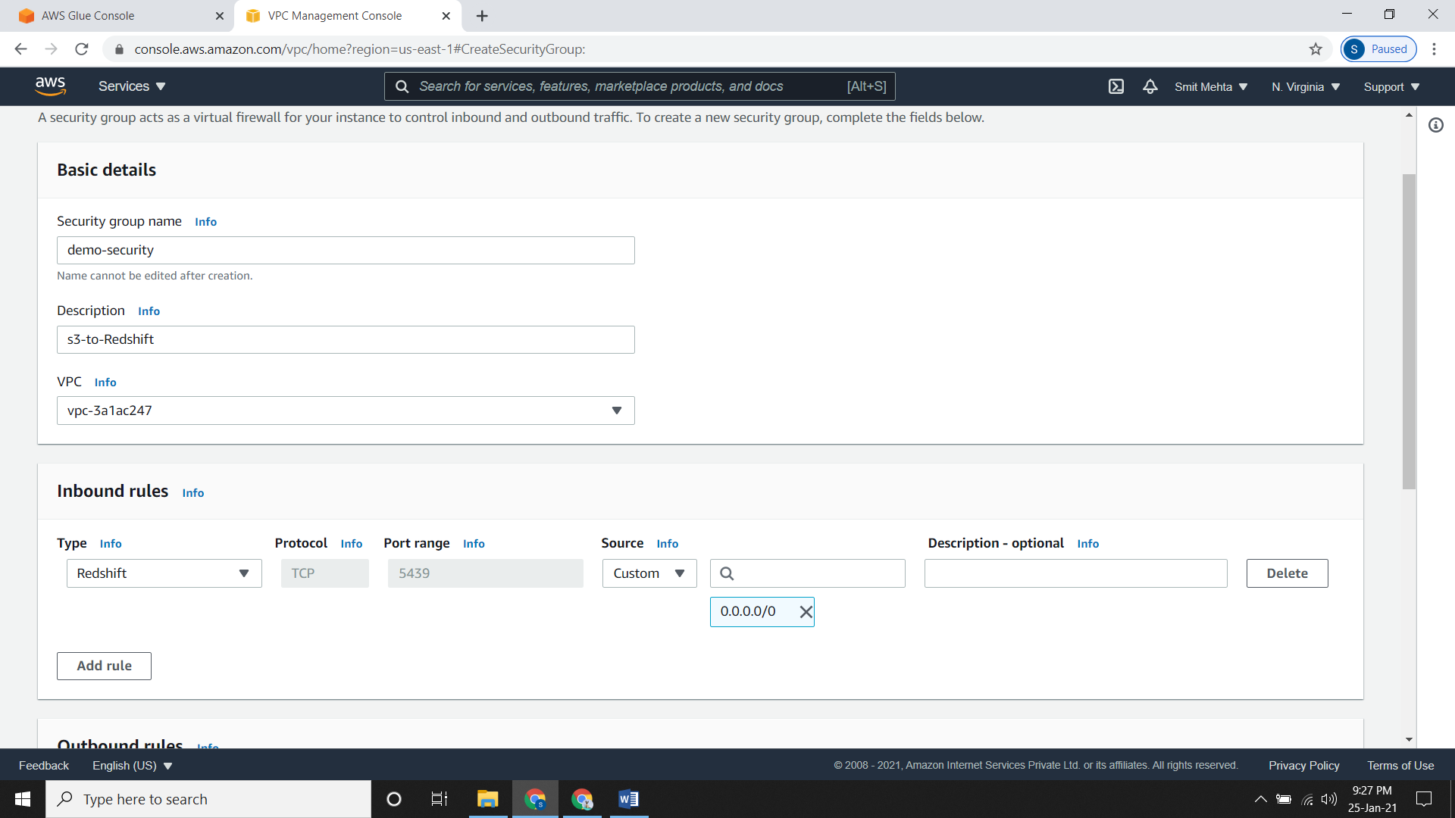

* Now we need to add a self-referencing for the same. So click on the security group and **edit Inbound rules.**
* **Type = All TCP and source = id of that security group** and then save it.

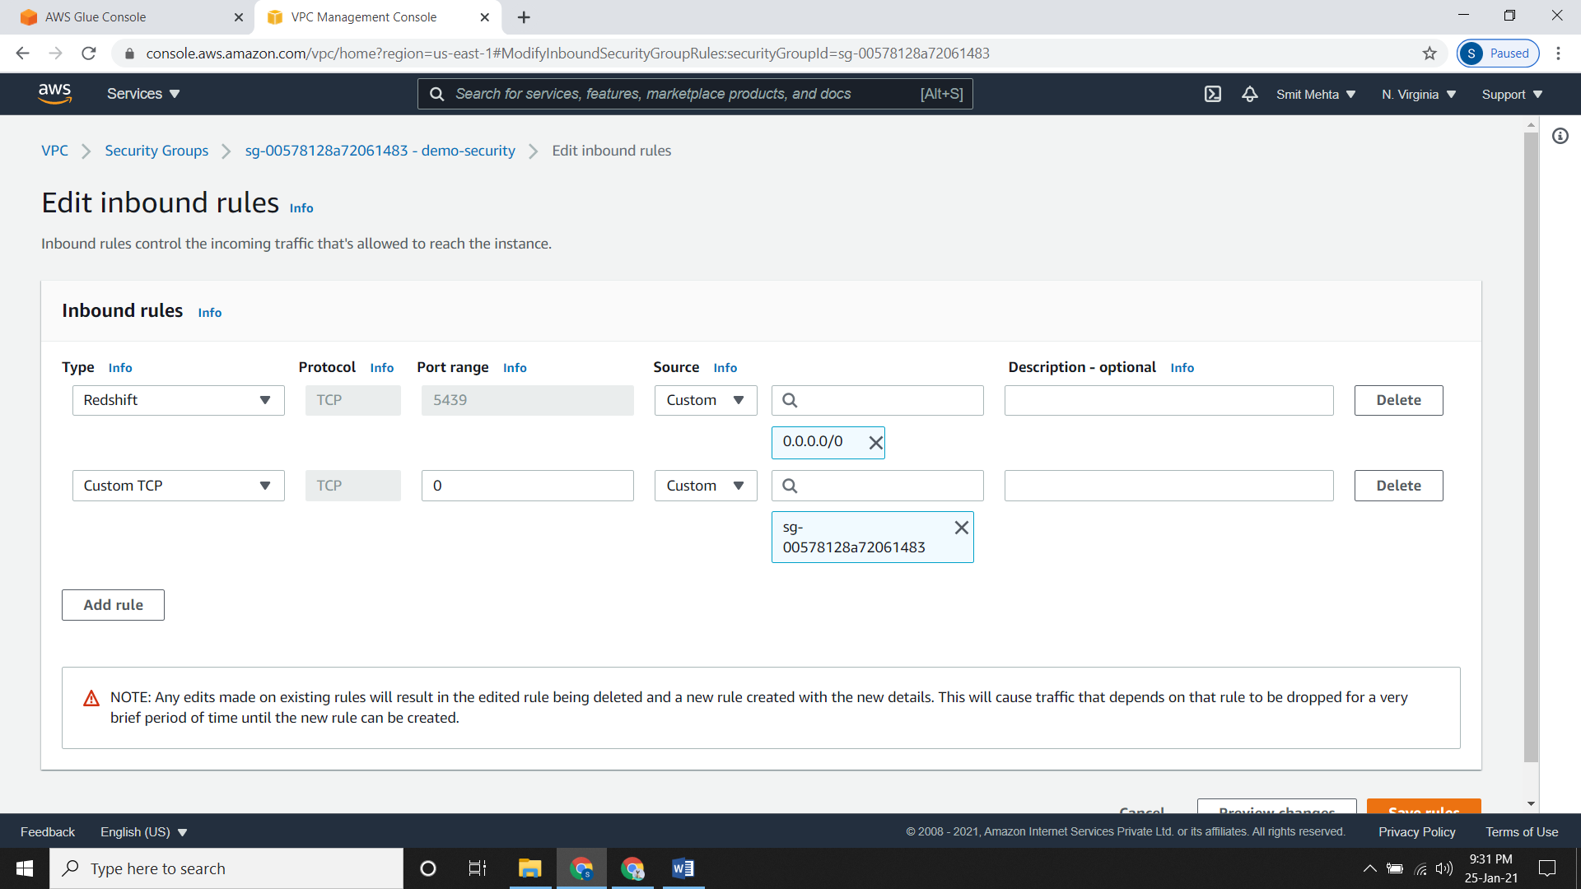

1. **Create AWS Glue Crawler:**

* It is same as creating a normal Crawler.
* Give a **Name,** then a **Source type** and a **Data Store.**
* Now give an **IAM role** from the existing one, if not just create a new one.
* Select the appropriate **Schedule** and the **output** of the crawler.
* Review it and create it.
* Now click on the crawler and click on **run crawler** for running it.
* So as the crawler is now running you can see the tables from the **Tables** section under the **Database** section.

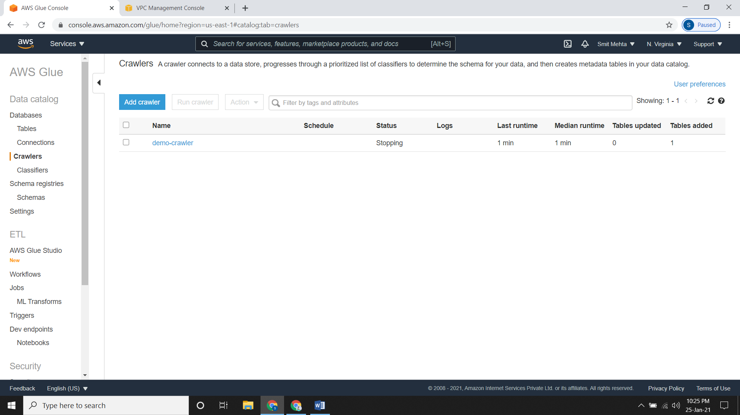

* Suppose if you want to edit you table, go to that **table** and click on **Edit Schema.**
* From here you can edit the table as you want. Here I’m editing the **datatype** of **birthday** **column** from **string to date.**
* After editing your table just click on **save** to save the tale.

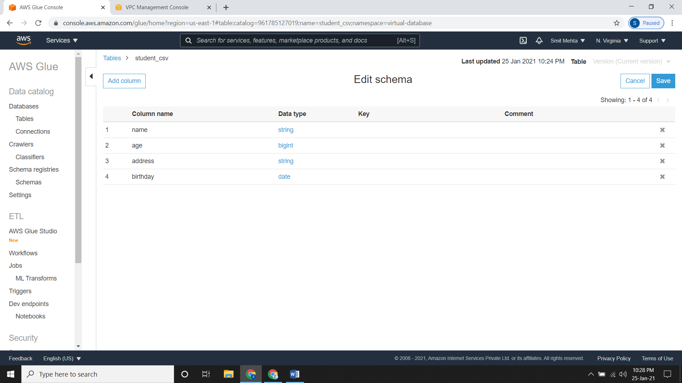

1. **Create Amazon Redshift Cluster:**

* Firstly, go to the **Amazon Redshift** console and here you need to create **Cluster Subnet Group.** So go to **Config** under that click on **create cluster subnet groups,** then give a **name description and VPC ID.** Now click on **Add all the subnets for this VPC** and create it.
* Now, go to the **Amazon Redshift** console and click on **create cluster.**
* Give a **name,** select the **Node type & number of Nodes** according to you.
* Under **Database configurations** give a database name and give the **Master user name & password.**
* Deselect the **Additional configurations** and under **Network and security,** choose the default **VPC** and in **VPC security groups** choose the security group which we had created. Then select the **cluster subnet group** which we had just created.
* In **Publicly accessible** field select **Yes** for it and then create the cluster.
* It will take approximately 3-4 minutes to start the cluster.

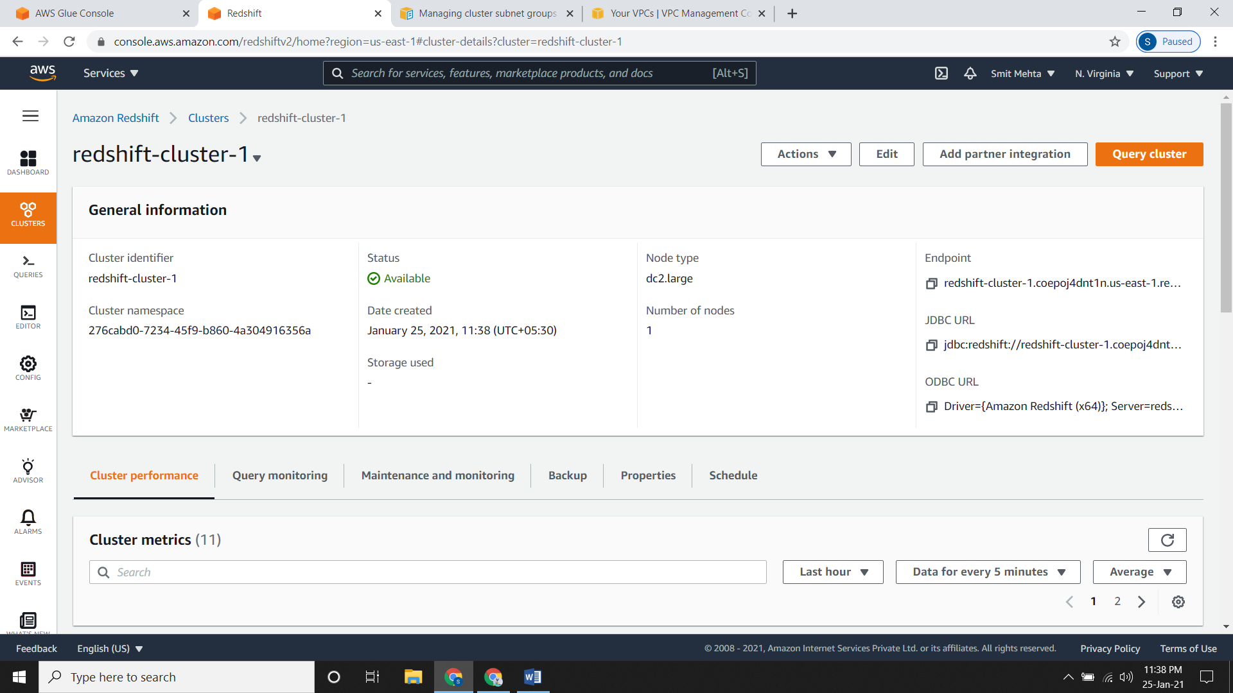

* After the cluster is ready, open it and click on **Editor.** Here you need to provide the information which is required.
* Now in **Select** **schema** choose **public** as we want to make it public and write a query to create a table according to your database.

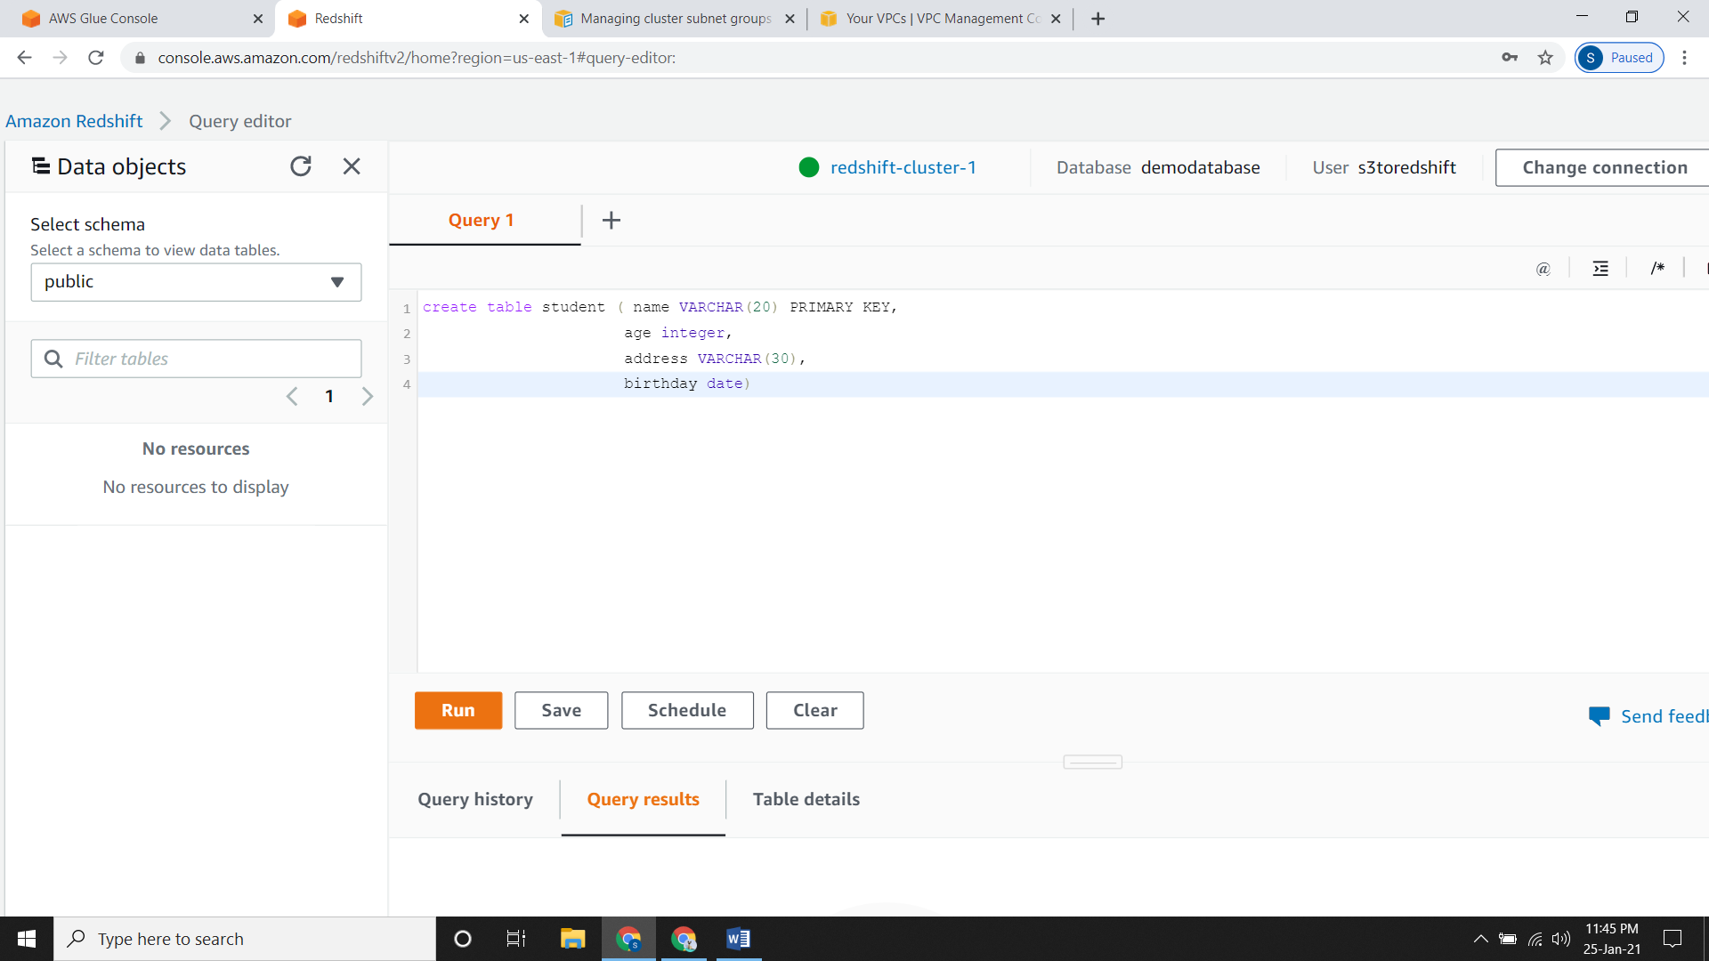

* After writing the just run your query.

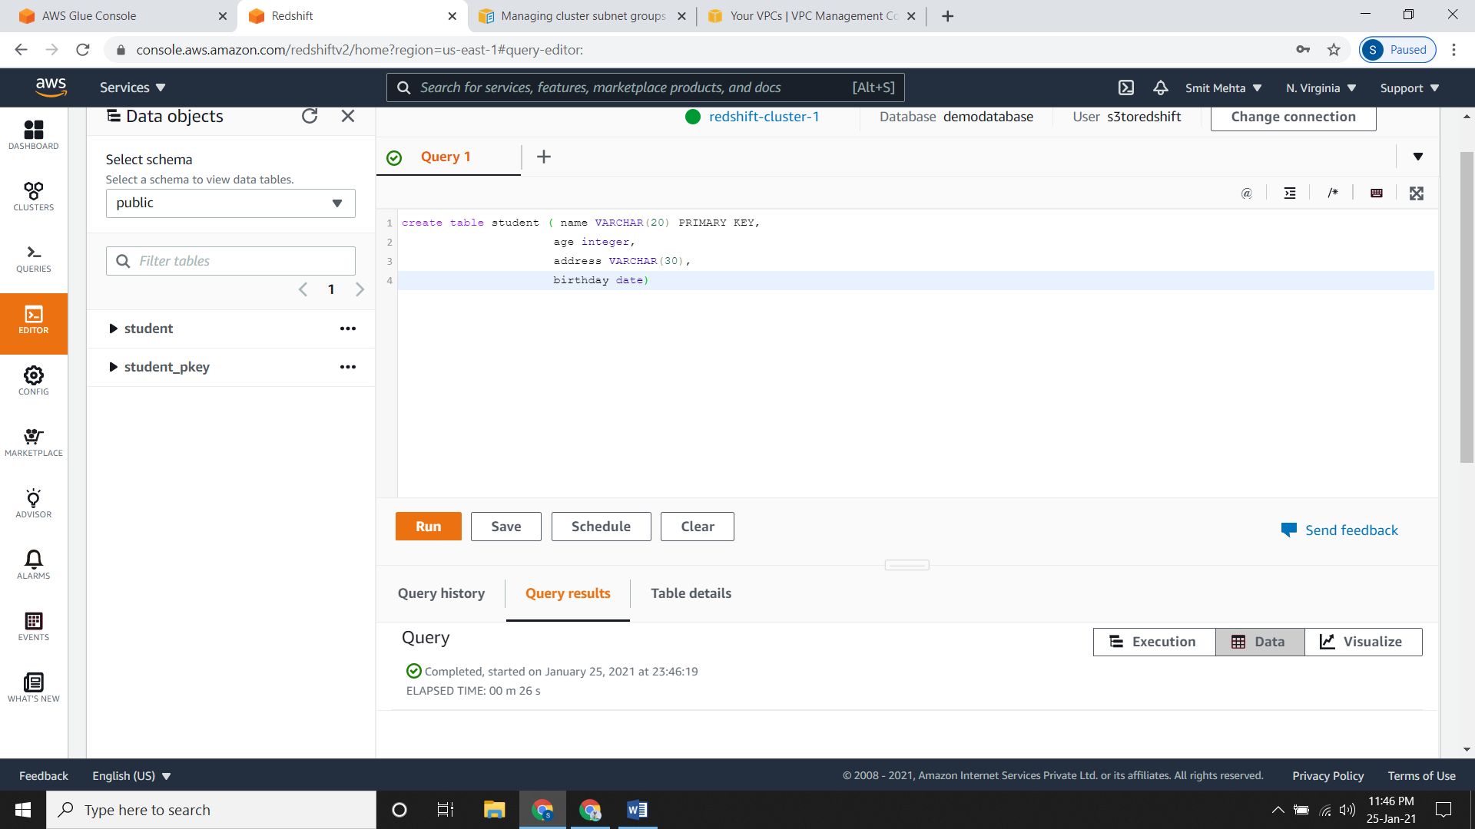

* Now select the **table name**, under options select **Show Schema**

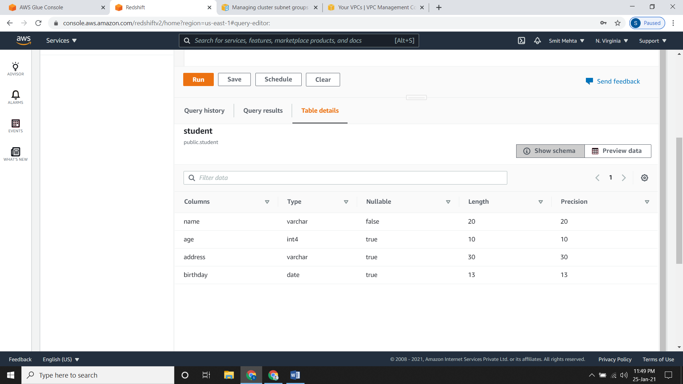

1. **Create JDBC Connection.**

* Now for connecting **Amazon Redshift** to **AWS Glue** we need to provide JDBC connections.
* Go to **AWS Glue console** and under **Data catalog** click on **Connections** and **Add a connection.**
* Now give it **Name** and in **connection** **type** select **Amazon** **Redshift**.
* Now select the **Cluster** which you have created and enter the **password** for it.

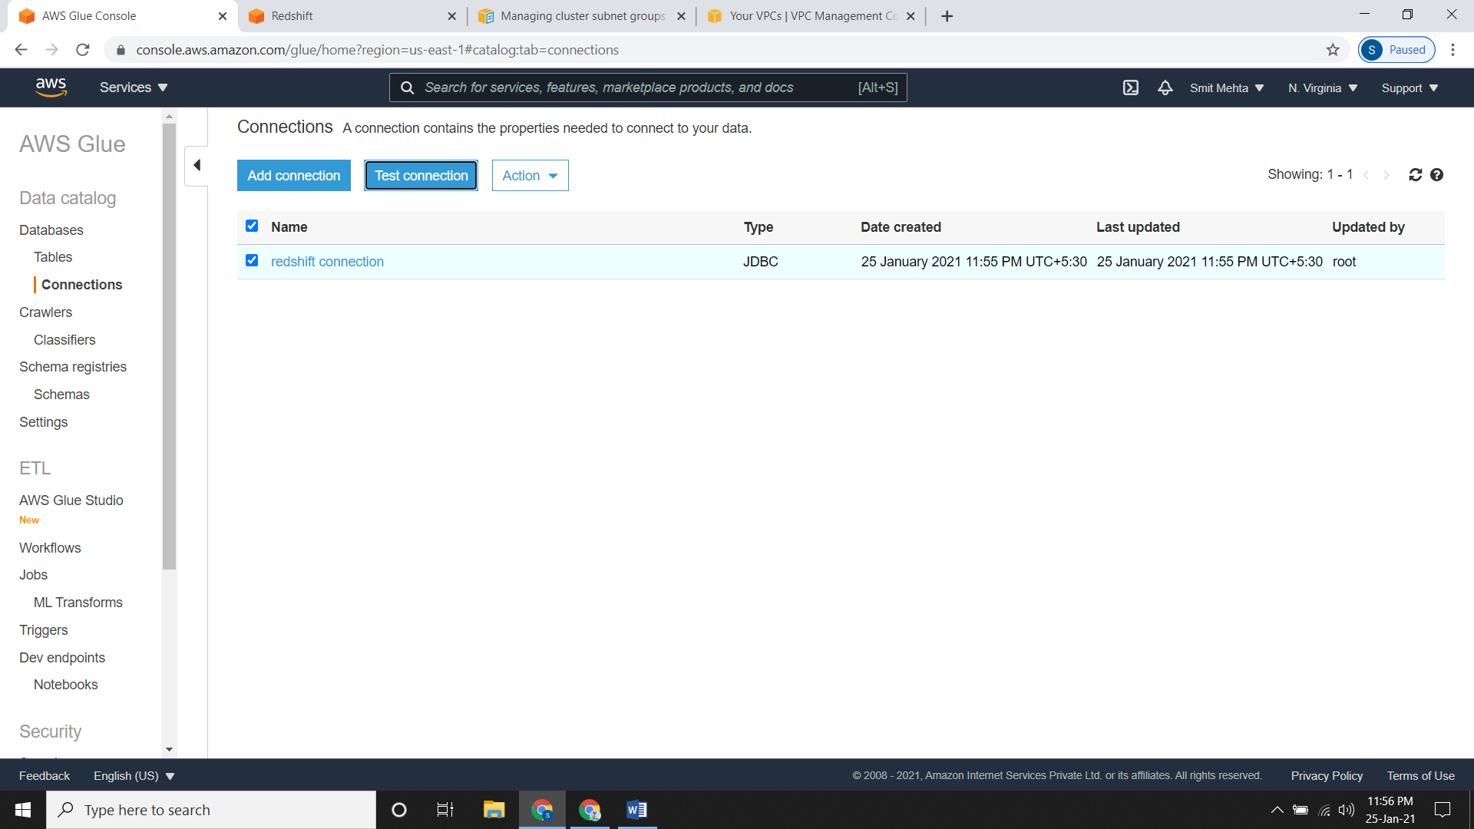

* Now select the connection and click on **Test connection** and here you need to provide the **IAM role** that you created while creating crawlers.
* Here there is a possibility that the connection would fail. Now here you need to add an inbound rule as **Type = All TCP, Port range = 0 – 65535 and source = 0.0.0.0/0**

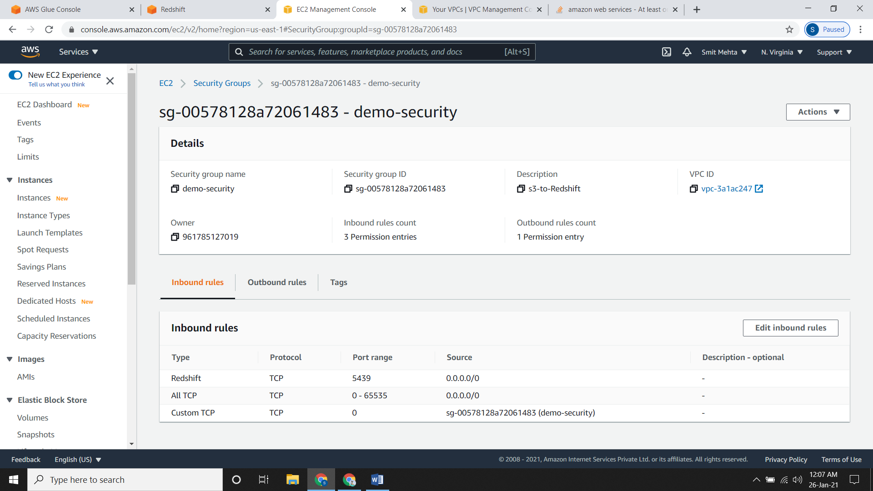

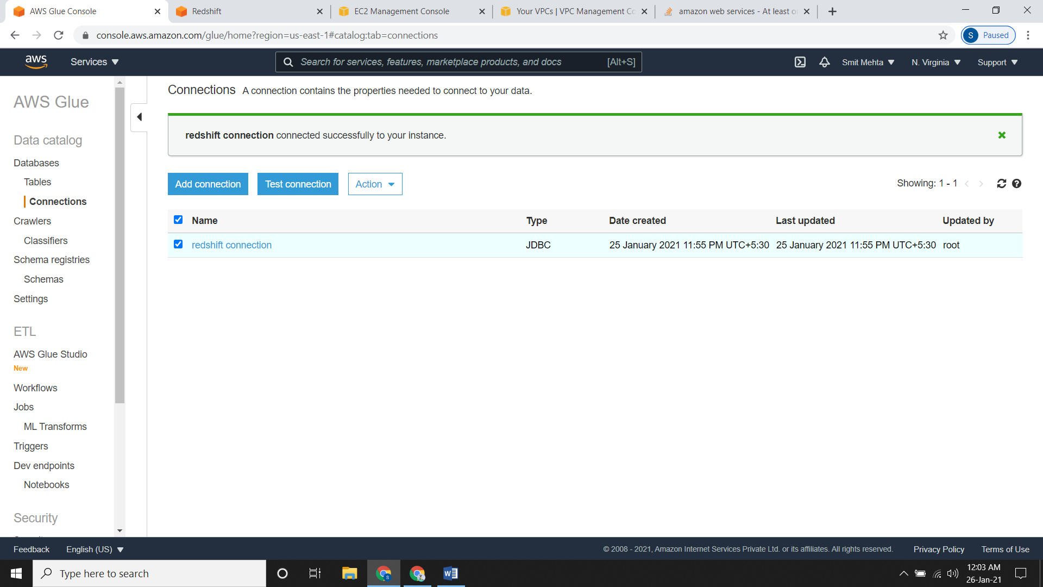

* Now you need to create a crawler as

**Data Store = JDBC,**

**Connection=connection_name &**

**Include path = database_name/schema/table_name**

* All other sections will be same as we have created a normal cluster.
* After creating the crawler just run it.

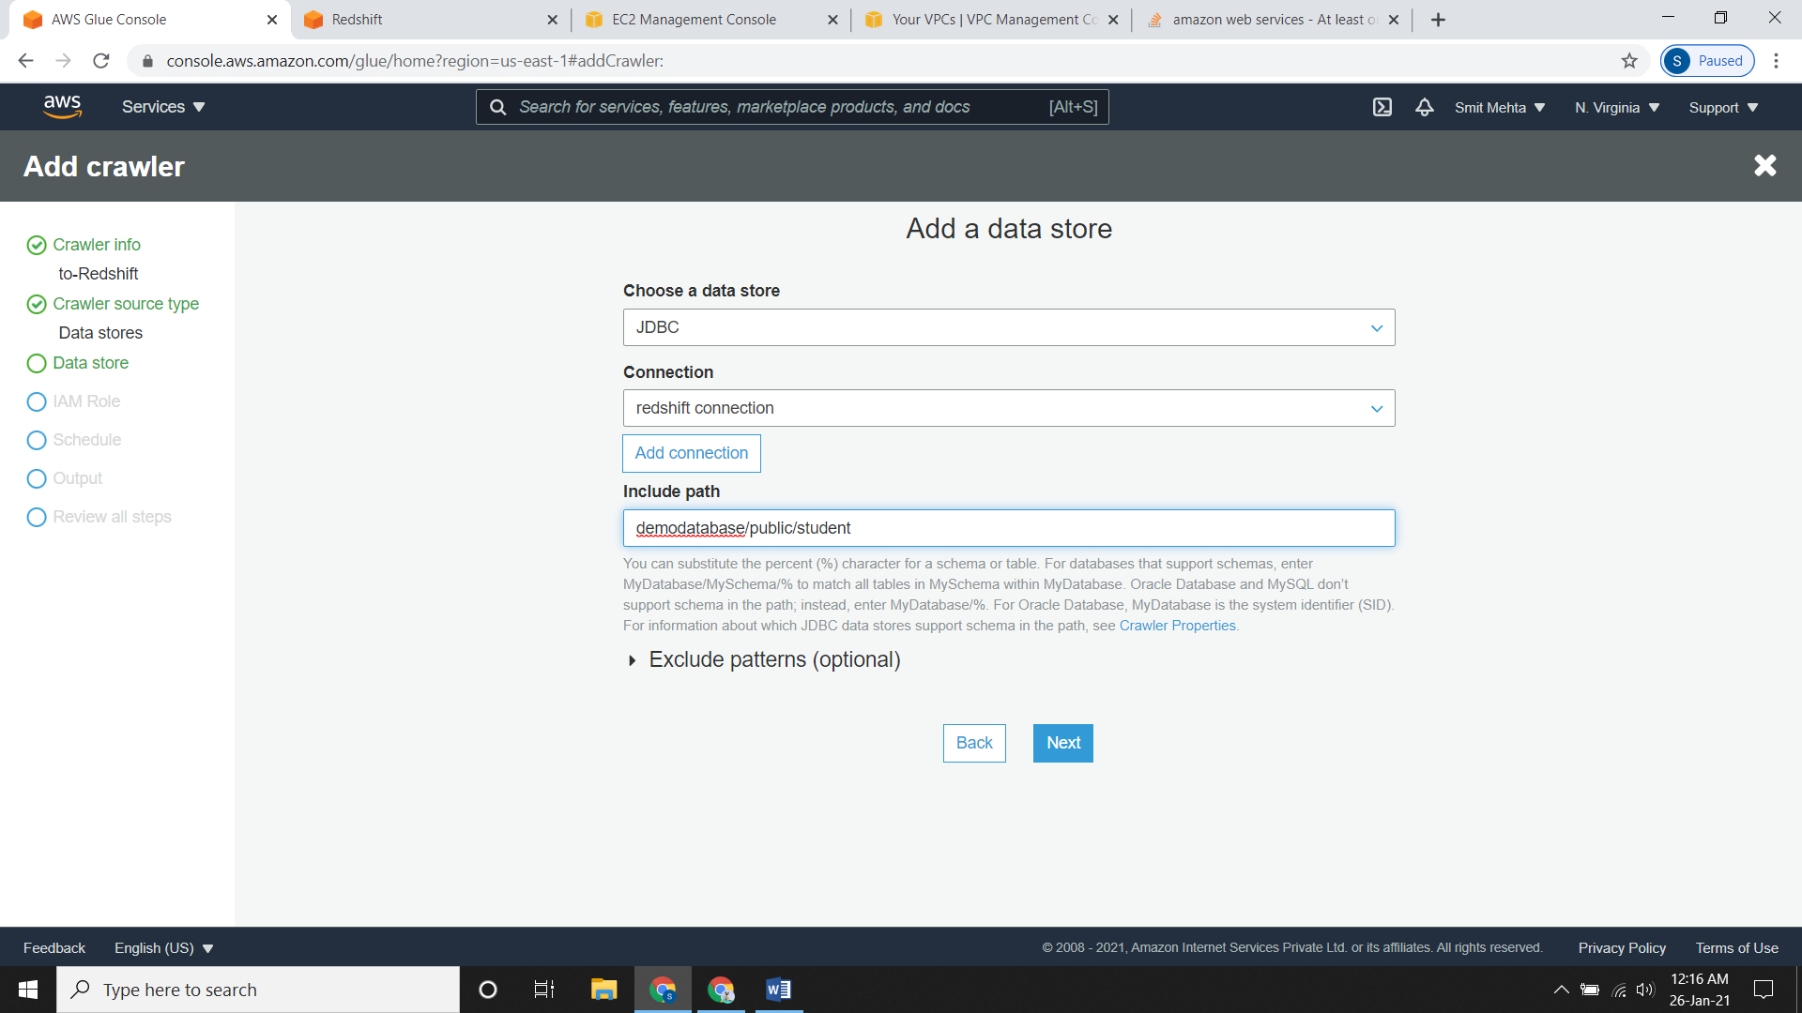

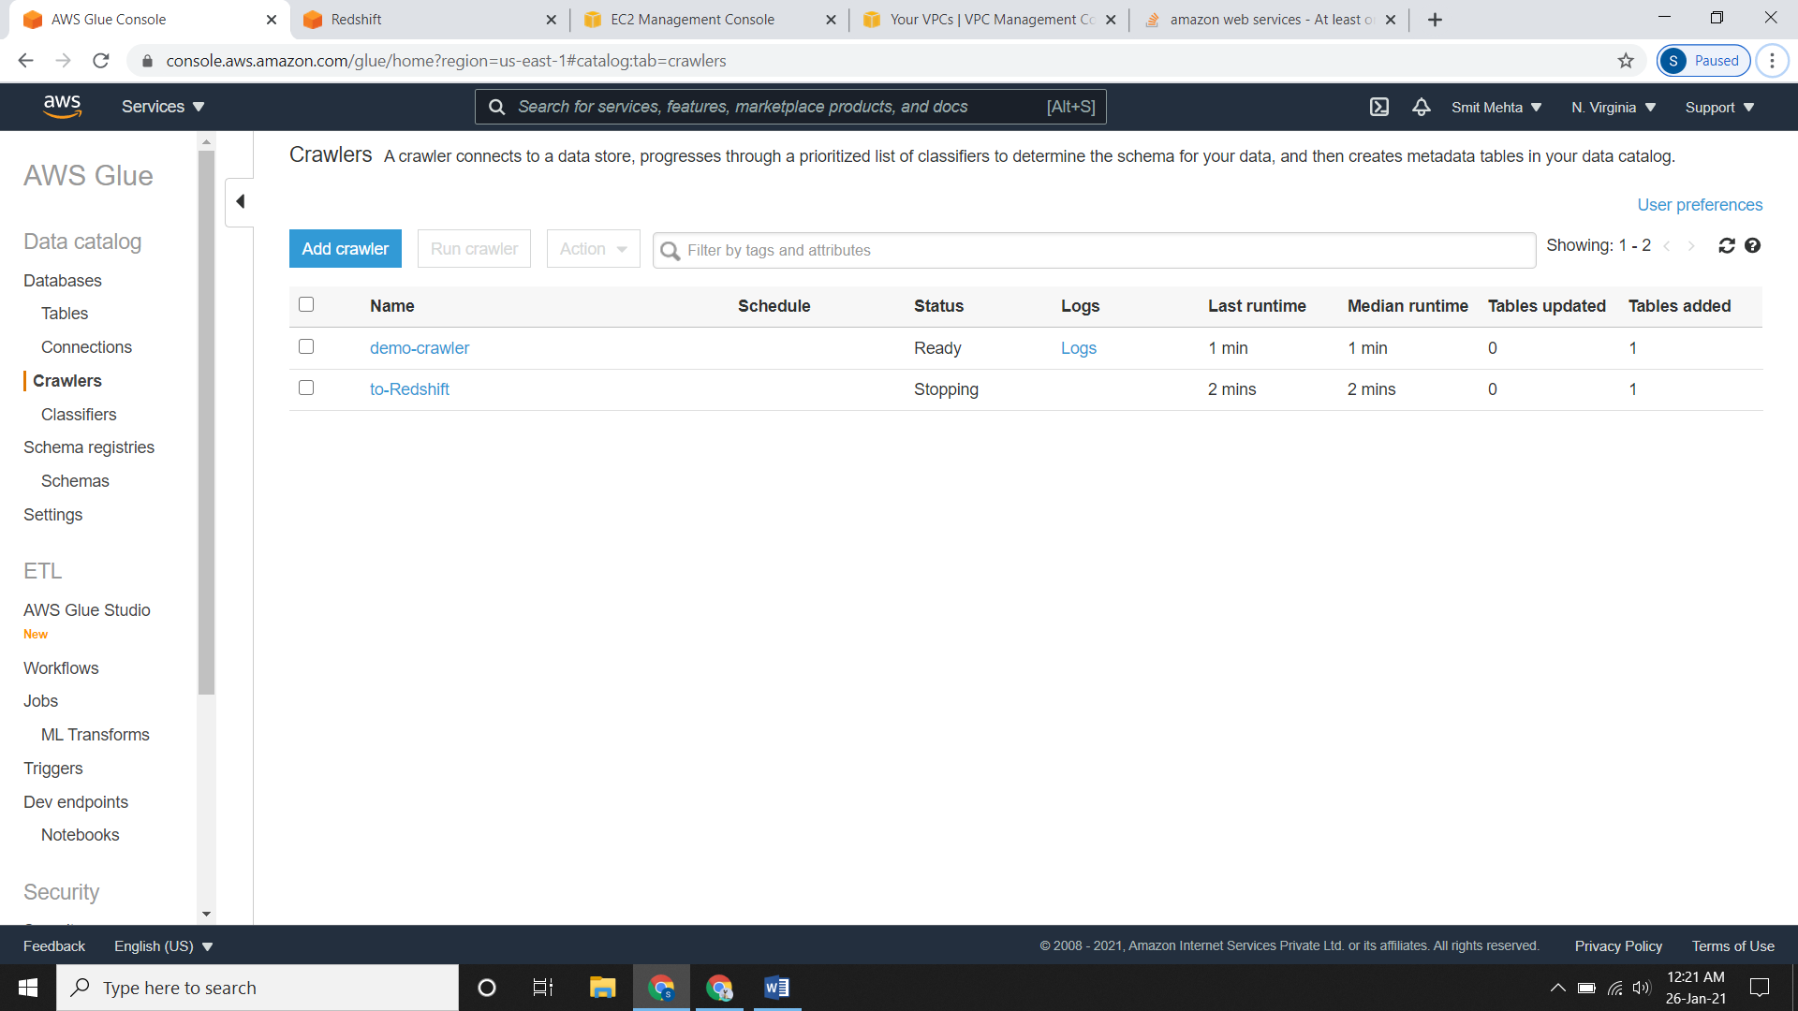

* After the crawler is in **Stopped** status check the tables.

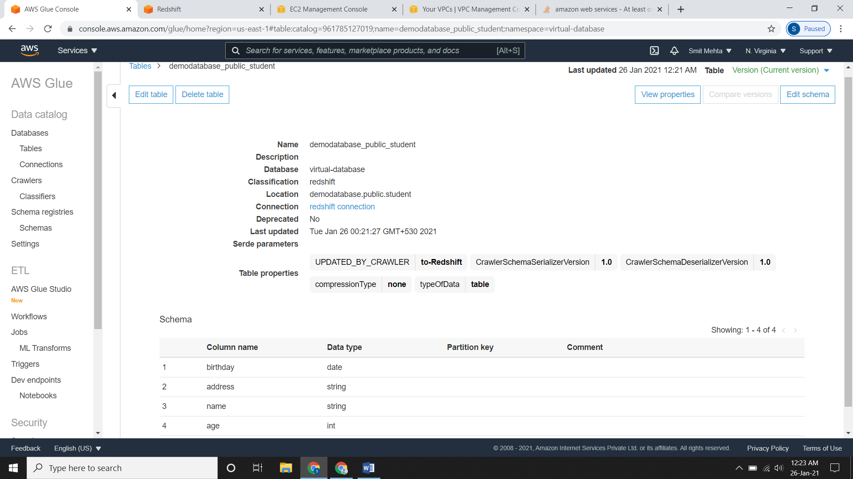

1. **Initialize ETL Job.**

* Here we need to create a **job** and give the script required.
* Here I will not change the script, the script will be the default script.

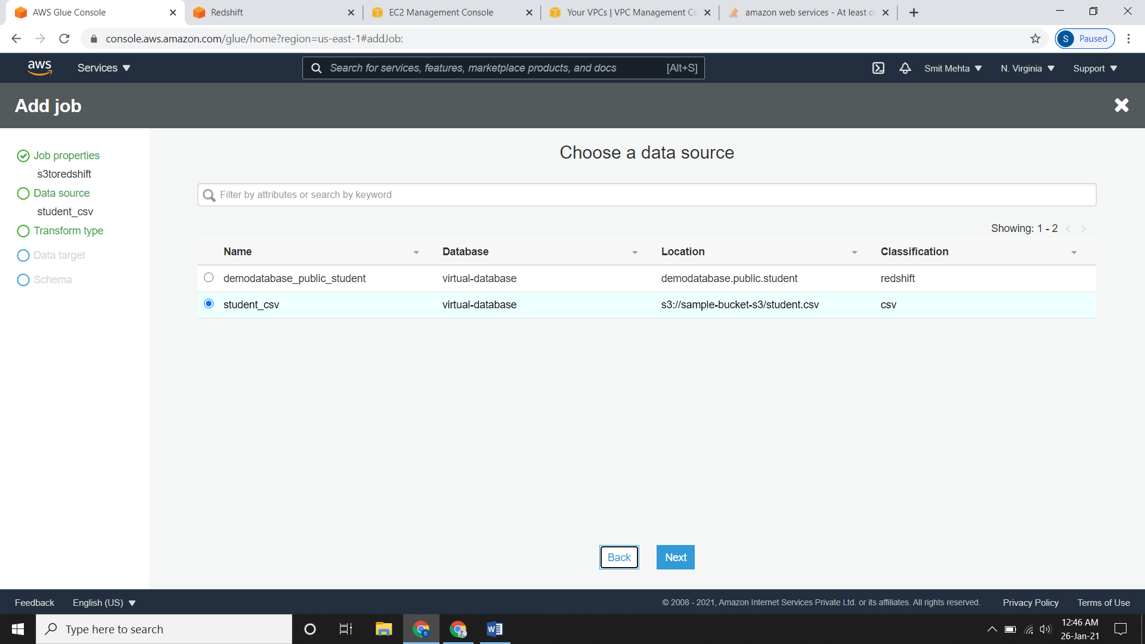

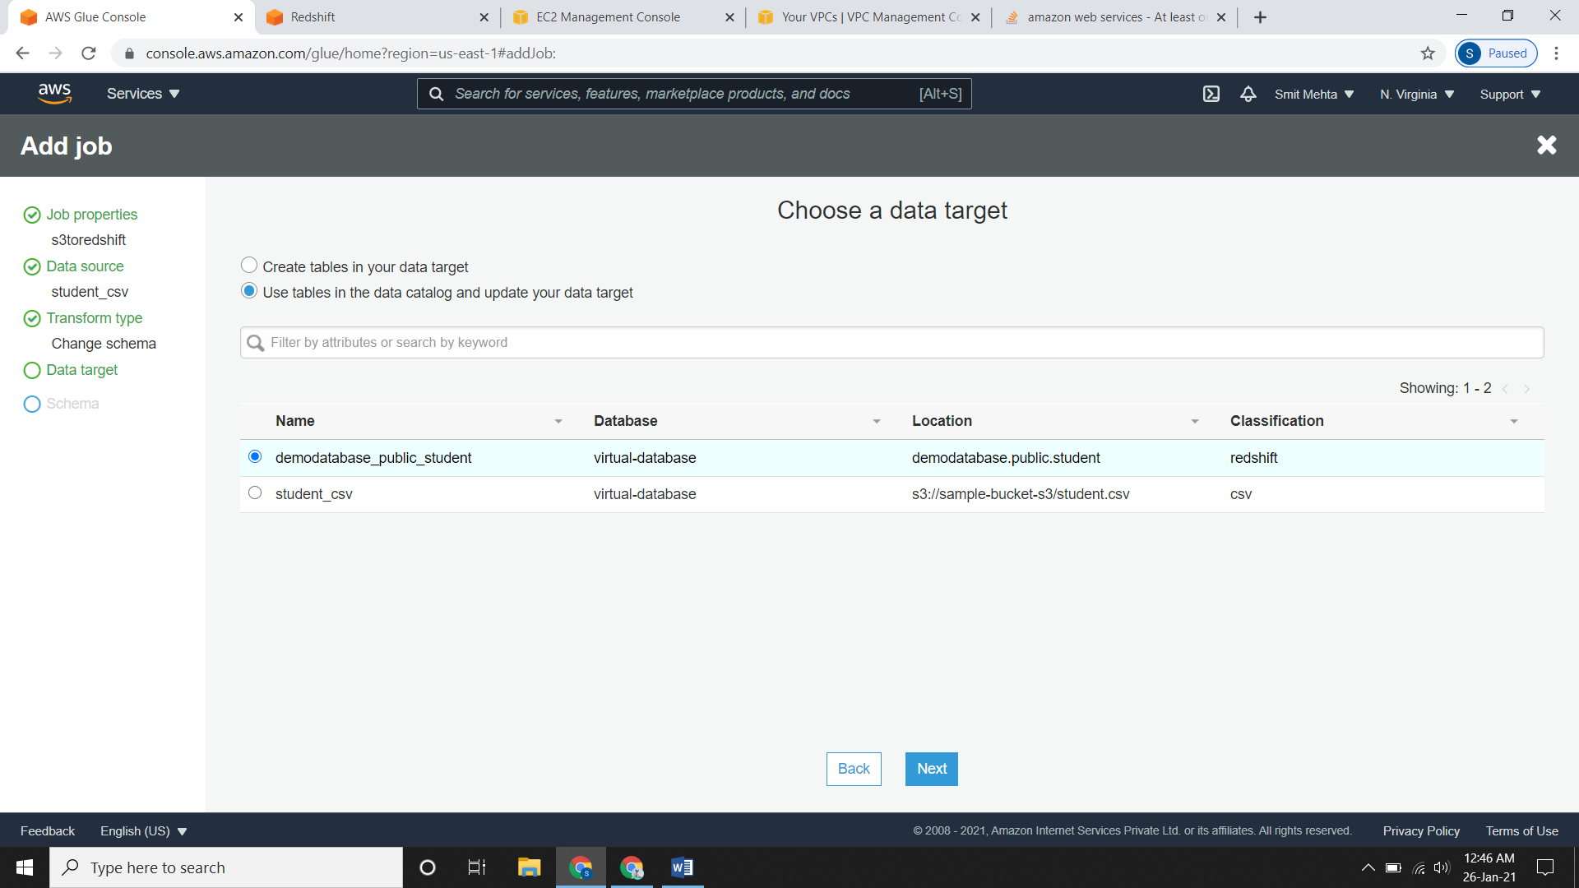

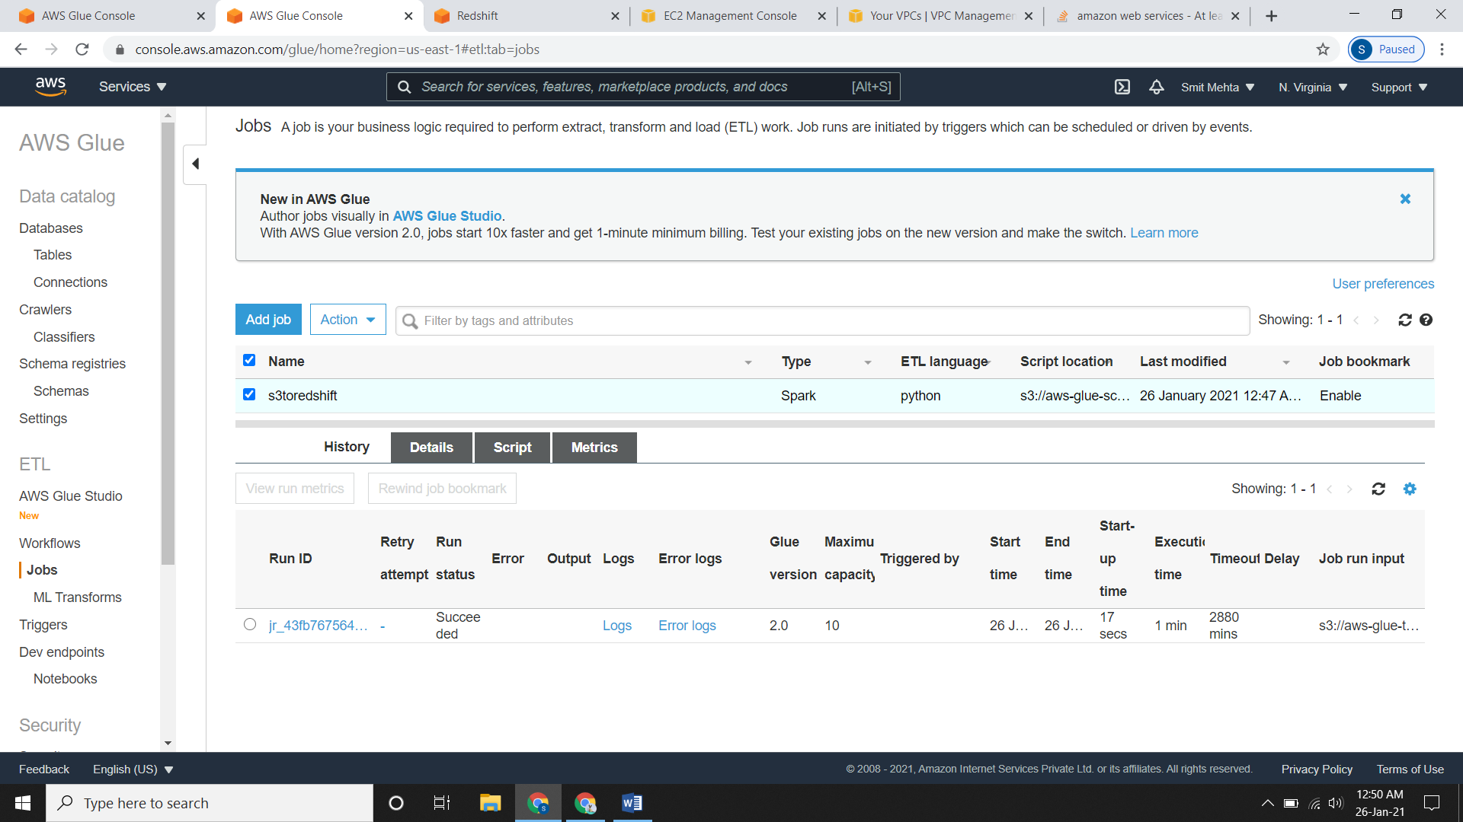

* Now go to **Redshift**, go to your cluster and click on **Editor**. Open it and select **public** as schema now select the **table** and under options select **show** **schema**.
* Now compare the **Preview Data** and **Recent Data/ Show Schema**
* **Preview Data**

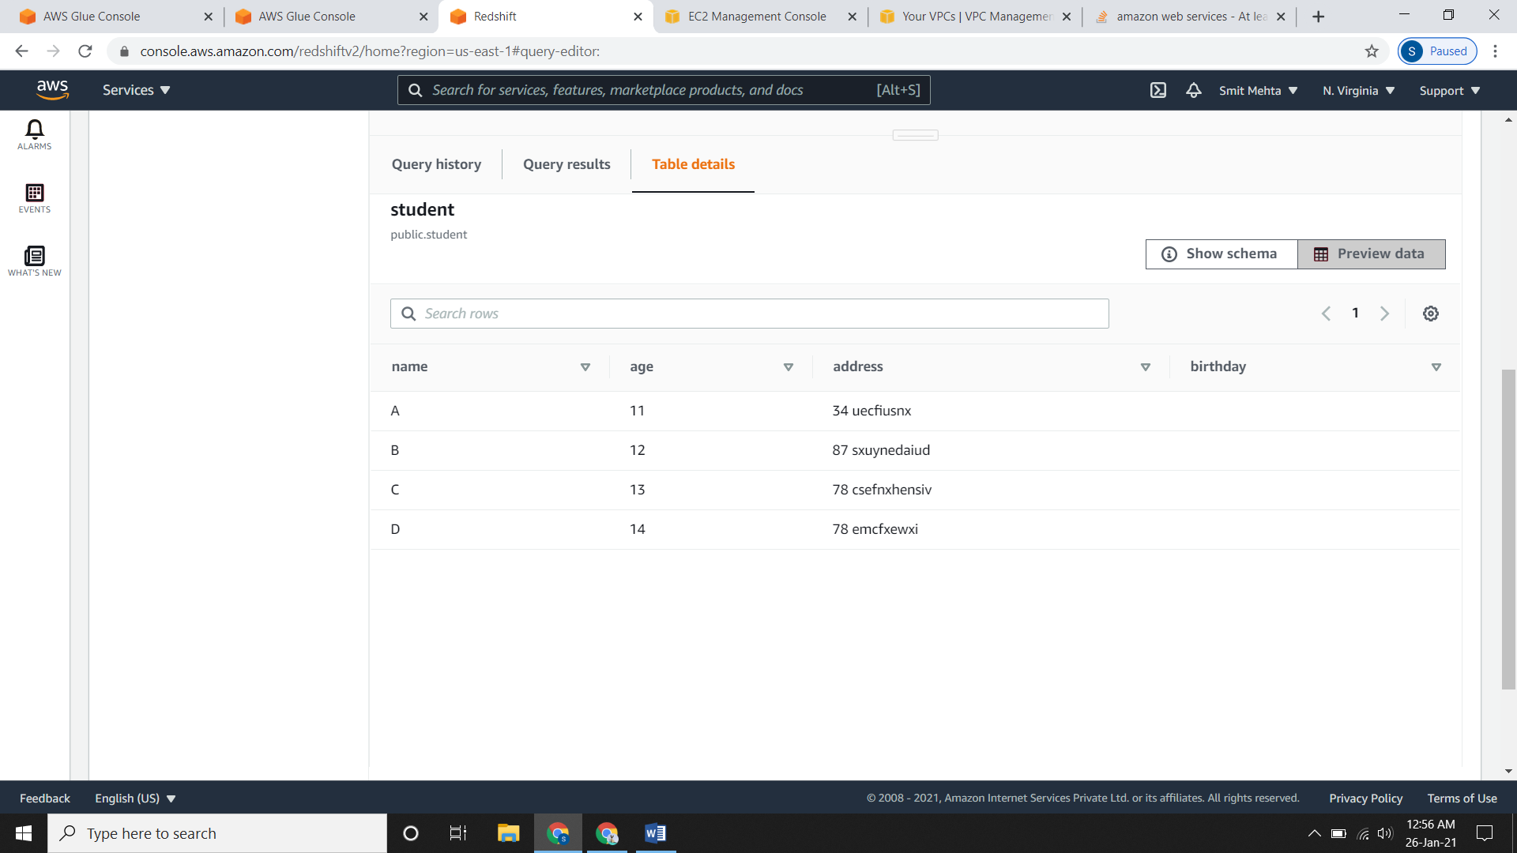

* **Recent Data/ Show Schema**

